**robotND1-proj4 Follow Me**

**01 – Project Intro**

That was a lot of information to take in, but now it's time to put it all into practice! In this project, you will build your own segmentation network, train it, validate it, and deploy it in the Follow Me project. In the end, you will have your own drone tracking and following a single hero target using your own network pipeline!

**[[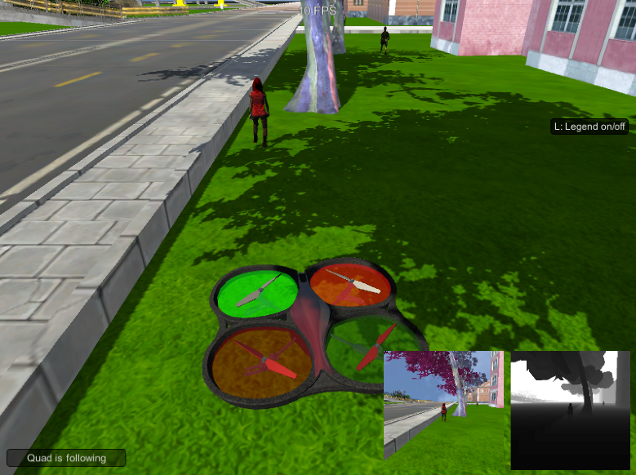](https://classroom.udacity.com/nanodegrees/nd209/parts/c199593e-1e9a-4830-8e29-2c86f70f489e/modules/cac27683-d5f4-40b4-82ce-d708de8f5373/lessons/197a058e-44f6-47df-8229-0ce633e0a2d0/concepts/a509e167-7370-41ed-ac2d-834076117008)](https://classroom.udacity.com/nanodegrees/nd209/parts/c199593e-1e9a-4830-8e29-2c86f70f489e/modules/cac27683-d5f4-40b4-82ce-d708de8f5373/lessons/197a058e-44f6-47df-8229-0ce633e0a2d0/concepts/a509e167-7370-41ed-ac2d-834076117008)**

**Project Steps:**

**1.** Setting up your local environment: This is how you will test your initial network design to make sure there are no errors. Otherwise, you can rack up charges on Amazon Web Services (AWS) with simple debugging instead of training. You will also use your local environment to evaluate your AWS trained model with the Follow Me simulator.

**2.** Setting up your AWS Amazon Machine Images (AMI).

**3.** Brief overview on how the simulator works and its basic controls.

**4.** Collecting data from the simulator to train your network.

**5.** Building your neural network.

**6.** Training your network and extracting your final model and weights from AWS.

**7.** Testing your model with the Follow Me simulator.

**8.** Getting your project ready for the final submission!

**02- Setting up your local environment**

Install Dependencies

The following instructions are meant to be carried out on your computer instead of the VM. **Note:** Currently, we will be working with TF version 1.2.1 for the rest of this module and will update to the latest TF version later.

### Prerequisites

The **RoboND** environment requires [**Python 3.5 64-bit**](https://www.python.org/downloads/) and [**Anaconda**](https://www.continuum.io/downloads). During the first week of the ND, you went through the installation for Anaconda. You can follow the steps pointed out [**here**](https://github.com/udacity/RoboND-Python-StarterKit/blob/master/doc/configure_via_anaconda.md) in case you want to reinstall the software.

Once you have Anaconda setup with the required Python version, run the following commands via the terminal or command line, to setup your environment:

**Note: if you have a recent version of the RoboND environment then these packages should already be installed.**

### OS X and Linux (Ubuntu)

source activate RoboND

pip install tensorflow==1.2.1

pip install socketIO-client

pip install transforms3d

pip install PyQt5

pip install pyqtgraph

### Windows

source activate RoboND

*# if the above throws an error, you can run "activate RoboND" instead*

pip install tensorflow==1.2.1

pip install socketIO-client

pip install transforms3d

pip install PyQt5

pip install pyqtgraph

**Note:**The above steps will help you install the CPU version for Tensorflow only.

Grab the Project Resources and the Simulator Binary

**Clone the repository**

$ git clone https://github.com/udacity/RoboND-DeepLearning-Project.git

**Download the QuadSim binary**

To interface your neural net with the QuadSim simulator, you must use a version QuadSim that has been custom tailored for this project. The previous version that you might have used for the Controls lab will not work.

The simulator binary can be downloaded [**here**](https://github.com/udacity/RoboND-DeepLearning-Project/releases/latest)

Grab the Data

Save the following three files into the data folder of the cloned repository.

[**Training Data**](https://s3-us-west-1.amazonaws.com/udacity-robotics/Deep+Learning+Data/Lab/train.zip)

[**Validation Data**](https://s3-us-west-1.amazonaws.com/udacity-robotics/Deep+Learning+Data/Lab/validation.zip)

[**Sample Evaluation Data**](https://s3-us-west-1.amazonaws.com/udacity-robotics/Deep+Learning+Data/Project/sample_evaluation_data.zip)

**03-Part2: setting up your AWS instance**

# AWS Setup

## Create an AWS account

* Instructions can be found [**here**](https://classroom.udacity.com/nanodegrees/nd209/parts/c199593e-1e9a-4830-8e29-2c86f70f489e/modules/cac27683-d5f4-40b4-82ce-d708de8f5373/lessons/dca6b1cd-5d40-41ab-a502-69a24c4b227e/concepts/bc84756d-22ba-448d-bad5-a63f99b3c693)

## Request a Limit increase

* Instructions can be found [**here**](https://classroom.udacity.com/nanodegrees/nd209/parts/c199593e-1e9a-4830-8e29-2c86f70f489e/modules/cac27683-d5f4-40b4-82ce-d708de8f5373/lessons/dca6b1cd-5d40-41ab-a502-69a24c4b227e/concepts/bc84756d-22ba-448d-bad5-a63f99b3c693)

## Create and Launch an EC2 instance

**1.** Open your [**AWS Console**](https://console.aws.amazon.com/console/)

**2.** Select **Services > Compute > EC2**

**[[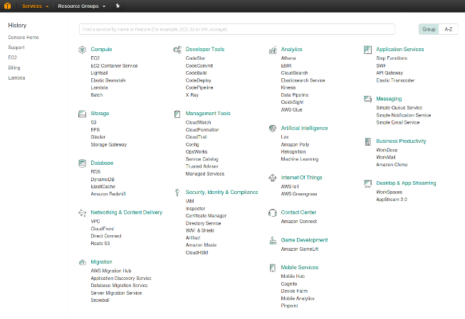](https://classroom.udacity.com/nanodegrees/nd209/parts/c199593e-1e9a-4830-8e29-2c86f70f489e/modules/cac27683-d5f4-40b4-82ce-d708de8f5373/lessons/197a058e-44f6-47df-8229-0ce633e0a2d0/concepts/27c73209-5d7b-4284-8315-c0e07a7cd87f)](https://classroom.udacity.com/nanodegrees/nd209/parts/c199593e-1e9a-4830-8e29-2c86f70f489e/modules/cac27683-d5f4-40b4-82ce-d708de8f5373/lessons/197a058e-44f6-47df-8229-0ce633e0a2d0/concepts/27c73209-5d7b-4284-8315-c0e07a7cd87f)**

**3.** To start using Amazon EC2, click the **Launch Instance** button

**[[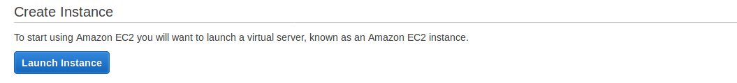](https://classroom.udacity.com/nanodegrees/nd209/parts/c199593e-1e9a-4830-8e29-2c86f70f489e/modules/cac27683-d5f4-40b4-82ce-d708de8f5373/lessons/197a058e-44f6-47df-8229-0ce633e0a2d0/concepts/27c73209-5d7b-4284-8315-c0e07a7cd87f)](https://classroom.udacity.com/nanodegrees/nd209/parts/c199593e-1e9a-4830-8e29-2c86f70f489e/modules/cac27683-d5f4-40b4-82ce-d708de8f5373/lessons/197a058e-44f6-47df-8229-0ce633e0a2d0/concepts/27c73209-5d7b-4284-8315-c0e07a7cd87f)**

**4.** Select an AMI. An AMI (Amazon Machine Image), is a template that contains the software configuration (operating system, application server, and applications) required to launch your instance:

* Select community AMIs from the left side panel

**[[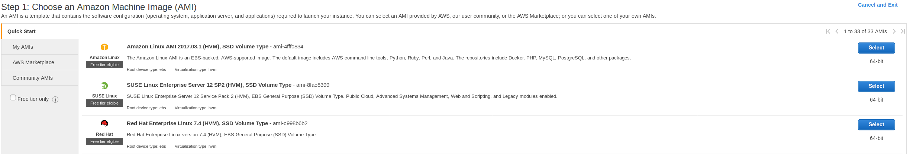](https://classroom.udacity.com/nanodegrees/nd209/parts/c199593e-1e9a-4830-8e29-2c86f70f489e/modules/cac27683-d5f4-40b4-82ce-d708de8f5373/lessons/197a058e-44f6-47df-8229-0ce633e0a2d0/concepts/27c73209-5d7b-4284-8315-c0e07a7cd87f)](https://classroom.udacity.com/nanodegrees/nd209/parts/c199593e-1e9a-4830-8e29-2c86f70f489e/modules/cac27683-d5f4-40b4-82ce-d708de8f5373/lessons/197a058e-44f6-47df-8229-0ce633e0a2d0/concepts/27c73209-5d7b-4284-8315-c0e07a7cd87f)**

* In the search box enter **Udacity Robotics**
* Click select for the AMI: **Udacity Robotics Deep Learning Laboratory**
* **Note: The AMI is available in the following regions: Oregon, North Virginia, Frankfurt, South America, Tokyo, Ohio, Seoul and Sydney. Also note that some regions may not cover p2.xlarge instances. If so, select another region.**

**[[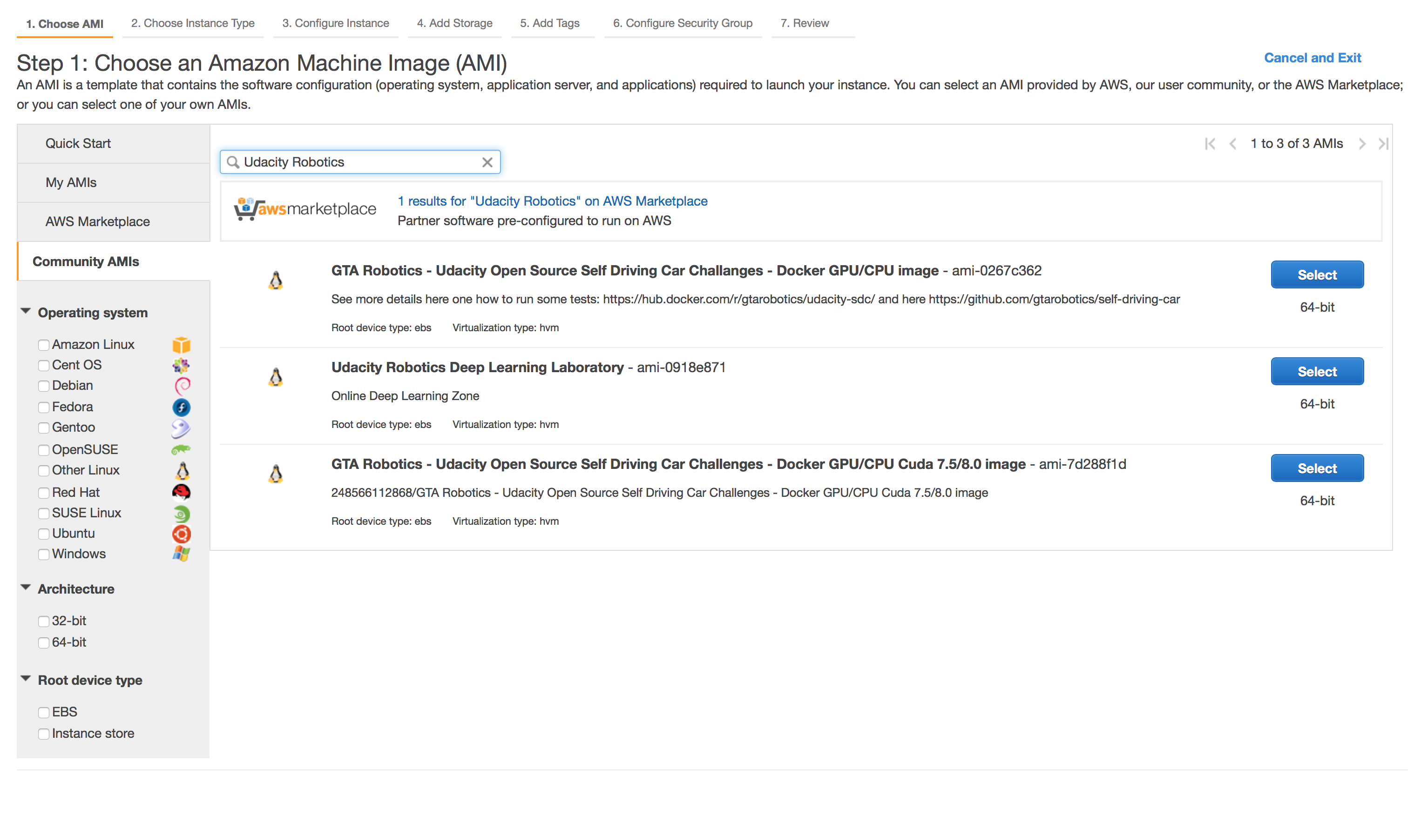](https://classroom.udacity.com/nanodegrees/nd209/parts/c199593e-1e9a-4830-8e29-2c86f70f489e/modules/cac27683-d5f4-40b4-82ce-d708de8f5373/lessons/197a058e-44f6-47df-8229-0ce633e0a2d0/concepts/27c73209-5d7b-4284-8315-c0e07a7cd87f)](https://classroom.udacity.com/nanodegrees/nd209/parts/c199593e-1e9a-4830-8e29-2c86f70f489e/modules/cac27683-d5f4-40b4-82ce-d708de8f5373/lessons/197a058e-44f6-47df-8229-0ce633e0a2d0/concepts/27c73209-5d7b-4284-8315-c0e07a7cd87f)**

**5.** Choose Instance type: Select a **p2.xlarge** instance

**[[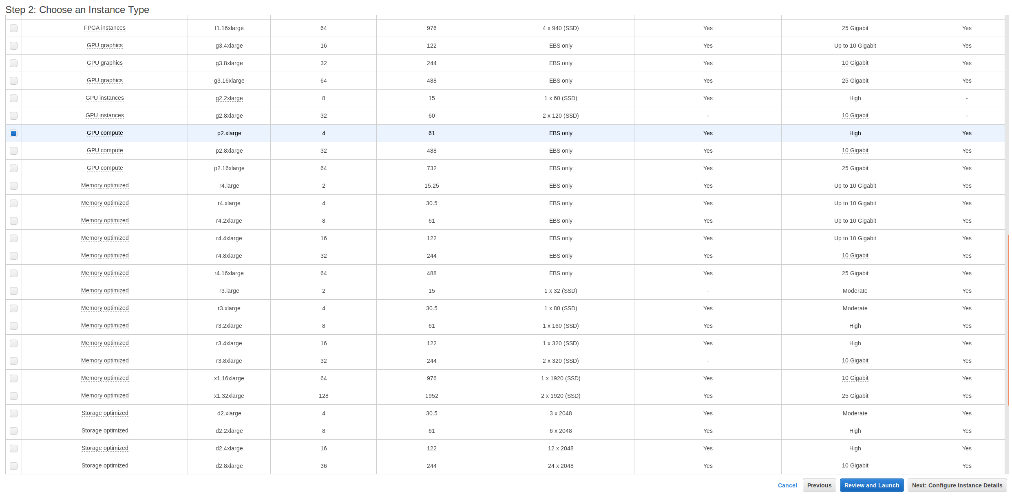](https://classroom.udacity.com/nanodegrees/nd209/parts/c199593e-1e9a-4830-8e29-2c86f70f489e/modules/cac27683-d5f4-40b4-82ce-d708de8f5373/lessons/197a058e-44f6-47df-8229-0ce633e0a2d0/concepts/27c73209-5d7b-4284-8315-c0e07a7cd87f)](https://classroom.udacity.com/nanodegrees/nd209/parts/c199593e-1e9a-4830-8e29-2c86f70f489e/modules/cac27683-d5f4-40b4-82ce-d708de8f5373/lessons/197a058e-44f6-47df-8229-0ce633e0a2d0/concepts/27c73209-5d7b-4284-8315-c0e07a7cd87f)**

**6.** Configure Instance Details: These details can be left the same, click **Next:Add Storage**

**[[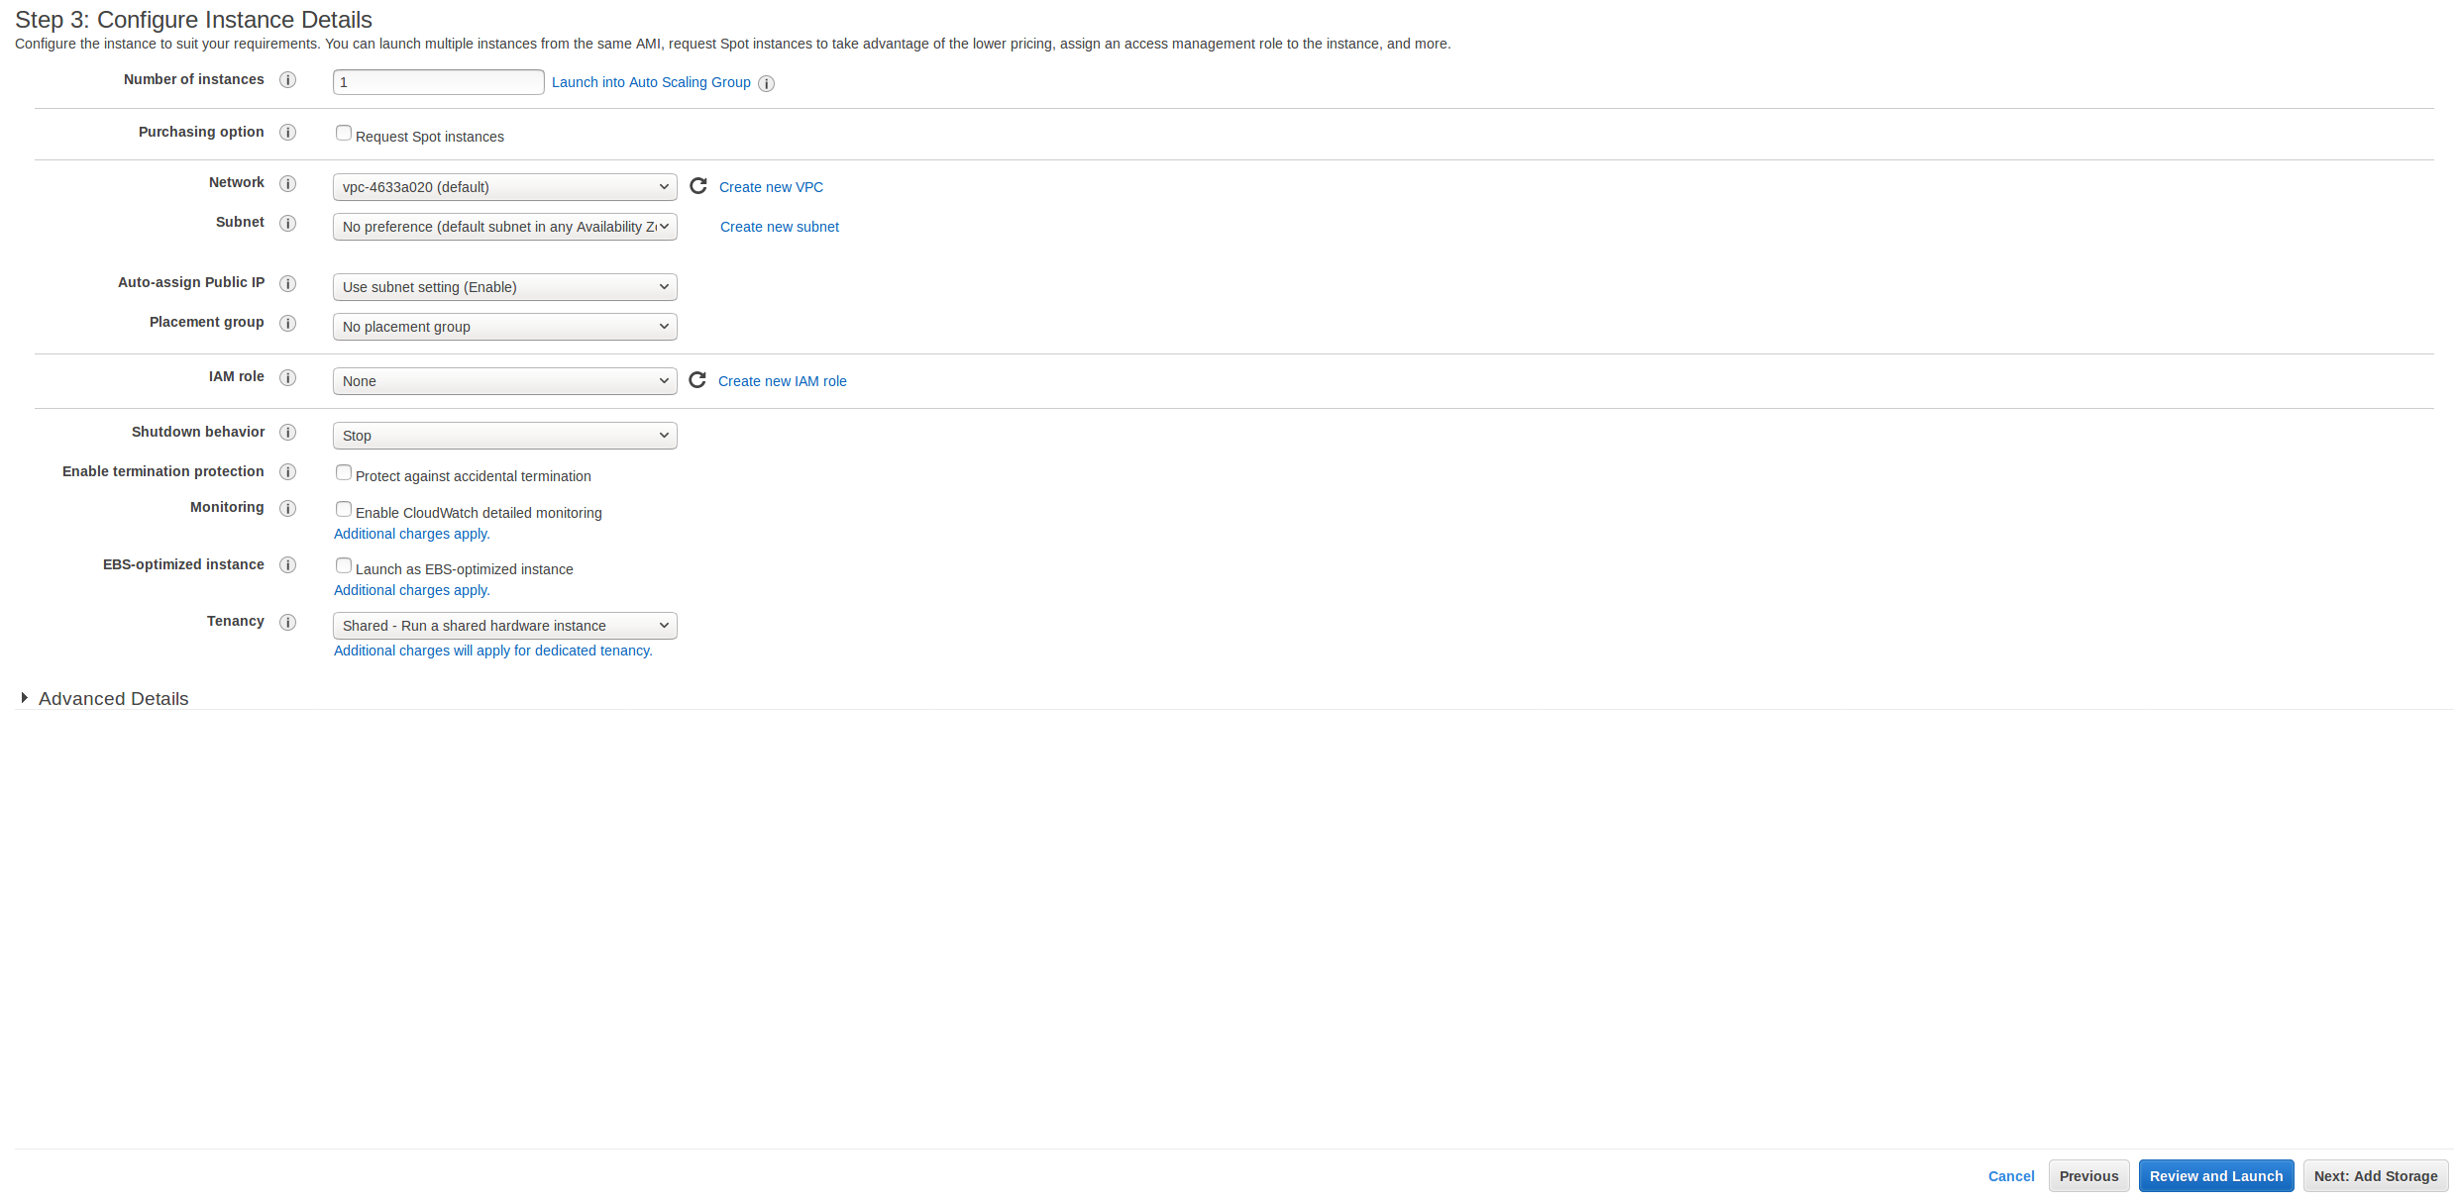](https://classroom.udacity.com/nanodegrees/nd209/parts/c199593e-1e9a-4830-8e29-2c86f70f489e/modules/cac27683-d5f4-40b4-82ce-d708de8f5373/lessons/197a058e-44f6-47df-8229-0ce633e0a2d0/concepts/27c73209-5d7b-4284-8315-c0e07a7cd87f)](https://classroom.udacity.com/nanodegrees/nd209/parts/c199593e-1e9a-4830-8e29-2c86f70f489e/modules/cac27683-d5f4-40b4-82ce-d708de8f5373/lessons/197a058e-44f6-47df-8229-0ce633e0a2d0/concepts/27c73209-5d7b-4284-8315-c0e07a7cd87f)**

**7.** Add Storage: If you would like to not have your data deleted between runs you can deselect **Delete on Termination** but keep in mind, this could potentially incur a small credit usage over time.

**[[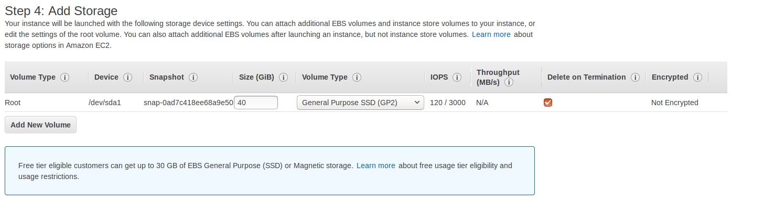](https://classroom.udacity.com/nanodegrees/nd209/parts/c199593e-1e9a-4830-8e29-2c86f70f489e/modules/cac27683-d5f4-40b4-82ce-d708de8f5373/lessons/197a058e-44f6-47df-8229-0ce633e0a2d0/concepts/27c73209-5d7b-4284-8315-c0e07a7cd87f)](https://classroom.udacity.com/nanodegrees/nd209/parts/c199593e-1e9a-4830-8e29-2c86f70f489e/modules/cac27683-d5f4-40b4-82ce-d708de8f5373/lessons/197a058e-44f6-47df-8229-0ce633e0a2d0/concepts/27c73209-5d7b-4284-8315-c0e07a7cd87f)**

**8.** Add Tags: No changes to be made here

**[[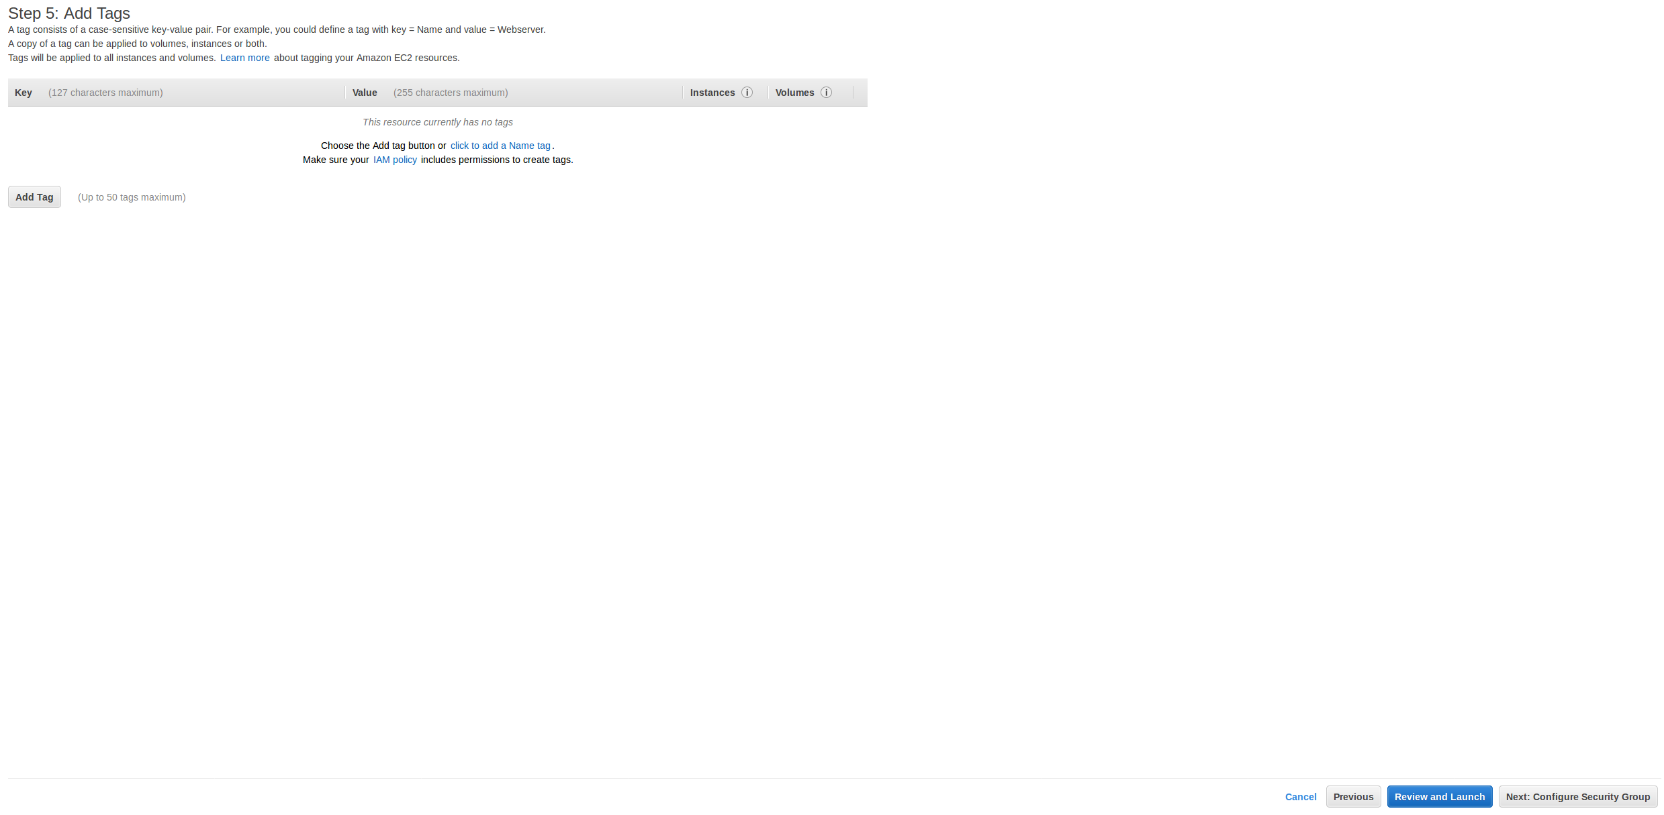](https://classroom.udacity.com/nanodegrees/nd209/parts/c199593e-1e9a-4830-8e29-2c86f70f489e/modules/cac27683-d5f4-40b4-82ce-d708de8f5373/lessons/197a058e-44f6-47df-8229-0ce633e0a2d0/concepts/27c73209-5d7b-4284-8315-c0e07a7cd87f)](https://classroom.udacity.com/nanodegrees/nd209/parts/c199593e-1e9a-4830-8e29-2c86f70f489e/modules/cac27683-d5f4-40b4-82ce-d708de8f5373/lessons/197a058e-44f6-47df-8229-0ce633e0a2d0/concepts/27c73209-5d7b-4284-8315-c0e07a7cd87f)**

**9.** Configure Security Group: Select **Create a new security group** and from the drop down box under **Source** select **My IP**

**[[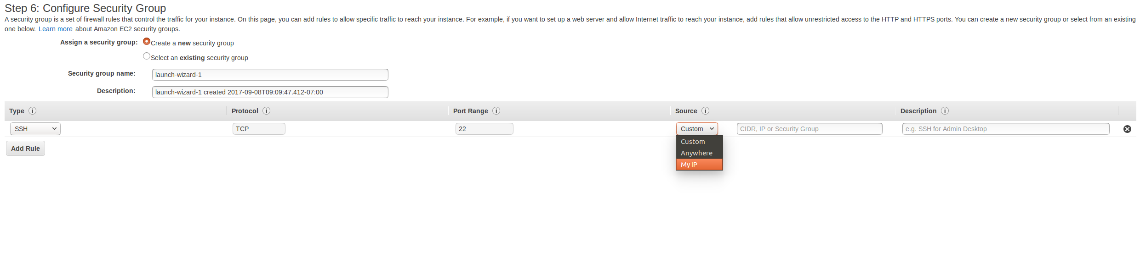](https://classroom.udacity.com/nanodegrees/nd209/parts/c199593e-1e9a-4830-8e29-2c86f70f489e/modules/cac27683-d5f4-40b4-82ce-d708de8f5373/lessons/197a058e-44f6-47df-8229-0ce633e0a2d0/concepts/27c73209-5d7b-4284-8315-c0e07a7cd87f)](https://classroom.udacity.com/nanodegrees/nd209/parts/c199593e-1e9a-4830-8e29-2c86f70f489e/modules/cac27683-d5f4-40b4-82ce-d708de8f5373/lessons/197a058e-44f6-47df-8229-0ce633e0a2d0/concepts/27c73209-5d7b-4284-8315-c0e07a7cd87f)**

**Note: If you plan to connect a Jupyter notebook to your AWS instance you will need to add one connection rule. Specifically, you will need to add a custom TCP rule to allow port 8888. and set the source to My IP. As seen below.**

**[[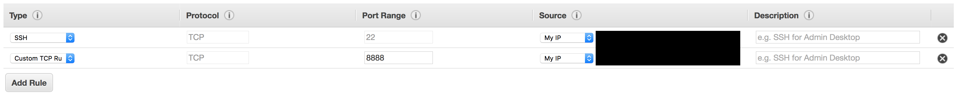](https://classroom.udacity.com/nanodegrees/nd209/parts/c199593e-1e9a-4830-8e29-2c86f70f489e/modules/cac27683-d5f4-40b4-82ce-d708de8f5373/lessons/197a058e-44f6-47df-8229-0ce633e0a2d0/concepts/27c73209-5d7b-4284-8315-c0e07a7cd87f)](https://classroom.udacity.com/nanodegrees/nd209/parts/c199593e-1e9a-4830-8e29-2c86f70f489e/modules/cac27683-d5f4-40b4-82ce-d708de8f5373/lessons/197a058e-44f6-47df-8229-0ce633e0a2d0/concepts/27c73209-5d7b-4284-8315-c0e07a7cd87f)**

**10.** Click **Review and Launch** button in the lower-right corner

**11.** On the review page click **Launch** in the lower-right corner

**[[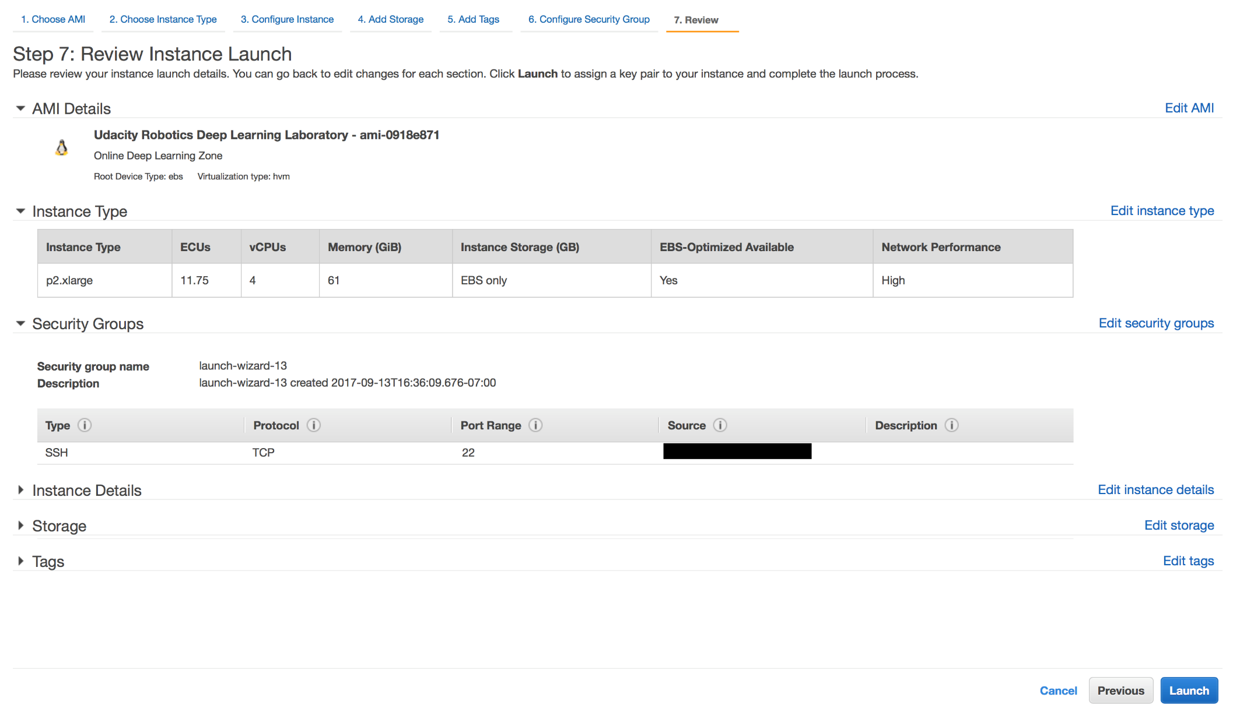](https://classroom.udacity.com/nanodegrees/nd209/parts/c199593e-1e9a-4830-8e29-2c86f70f489e/modules/cac27683-d5f4-40b4-82ce-d708de8f5373/lessons/197a058e-44f6-47df-8229-0ce633e0a2d0/concepts/27c73209-5d7b-4284-8315-c0e07a7cd87f)](https://classroom.udacity.com/nanodegrees/nd209/parts/c199593e-1e9a-4830-8e29-2c86f70f489e/modules/cac27683-d5f4-40b4-82ce-d708de8f5373/lessons/197a058e-44f6-47df-8229-0ce633e0a2d0/concepts/27c73209-5d7b-4284-8315-c0e07a7cd87f)**

**12.** Click the check box to select key pair, if you have not created a key pair you can create a new key pair right here

**[[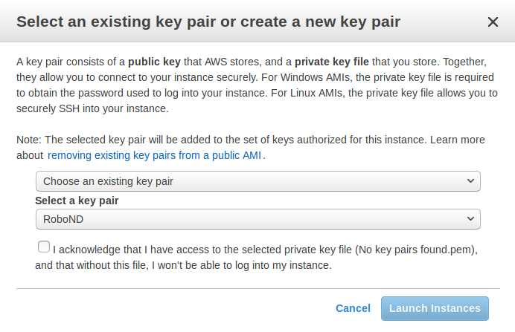](https://classroom.udacity.com/nanodegrees/nd209/parts/c199593e-1e9a-4830-8e29-2c86f70f489e/modules/cac27683-d5f4-40b4-82ce-d708de8f5373/lessons/197a058e-44f6-47df-8229-0ce633e0a2d0/concepts/27c73209-5d7b-4284-8315-c0e07a7cd87f)](https://classroom.udacity.com/nanodegrees/nd209/parts/c199593e-1e9a-4830-8e29-2c86f70f489e/modules/cac27683-d5f4-40b4-82ce-d708de8f5373/lessons/197a058e-44f6-47df-8229-0ce633e0a2d0/concepts/27c73209-5d7b-4284-8315-c0e07a7cd87f)**

**13.** Finally click **Launch instances**

**14.** If you get an error saying you do not have any instances of the chosen type available, make sure your Limit Increase request has been approved.

**15.** You may click **View Instances** to see the instance you just launched

**[[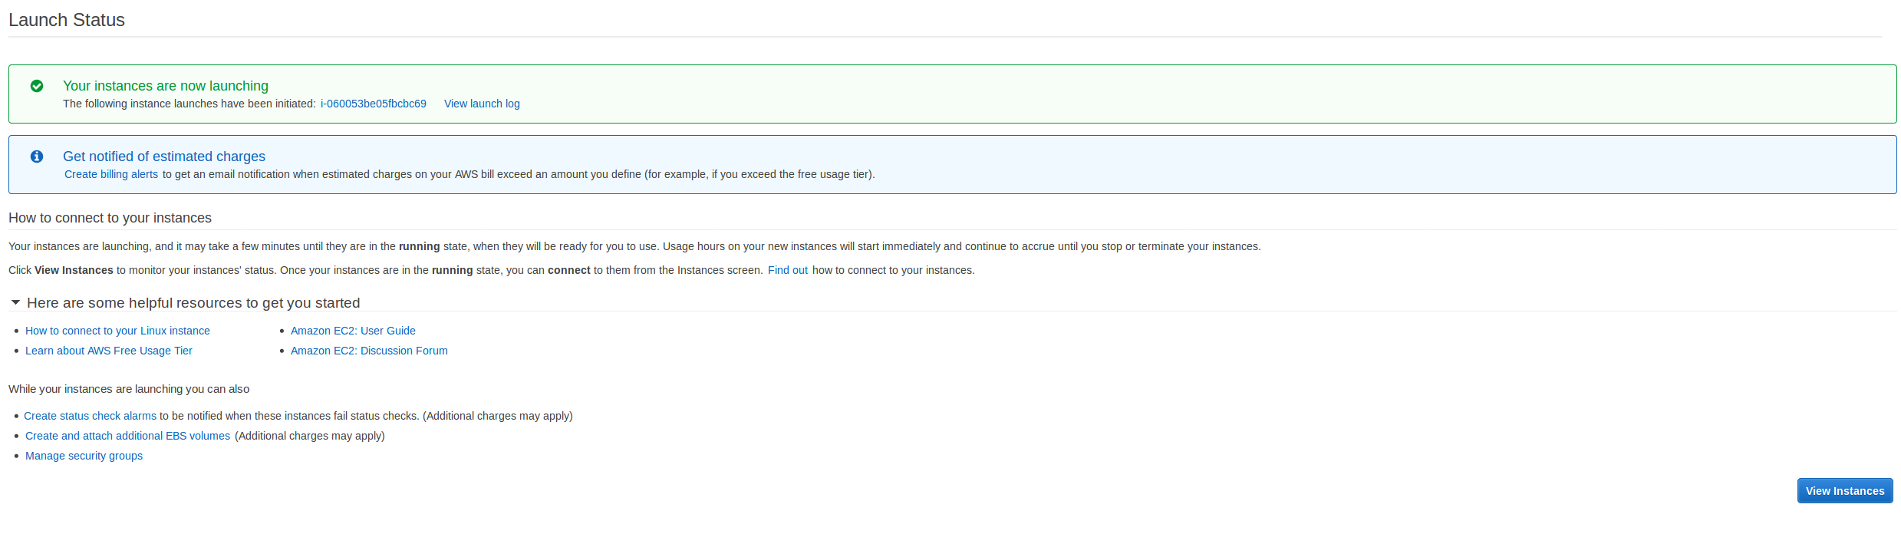](https://classroom.udacity.com/nanodegrees/nd209/parts/c199593e-1e9a-4830-8e29-2c86f70f489e/modules/cac27683-d5f4-40b4-82ce-d708de8f5373/lessons/197a058e-44f6-47df-8229-0ce633e0a2d0/concepts/27c73209-5d7b-4284-8315-c0e07a7cd87f)](https://classroom.udacity.com/nanodegrees/nd209/parts/c199593e-1e9a-4830-8e29-2c86f70f489e/modules/cac27683-d5f4-40b4-82ce-d708de8f5373/lessons/197a058e-44f6-47df-8229-0ce633e0a2d0/concepts/27c73209-5d7b-4284-8315-c0e07a7cd87f)**

## Connecting to an EC2 Instance

**1.** At anytime you can access your **EC2 Dashboard** by selecting **Services > EC2**

**[[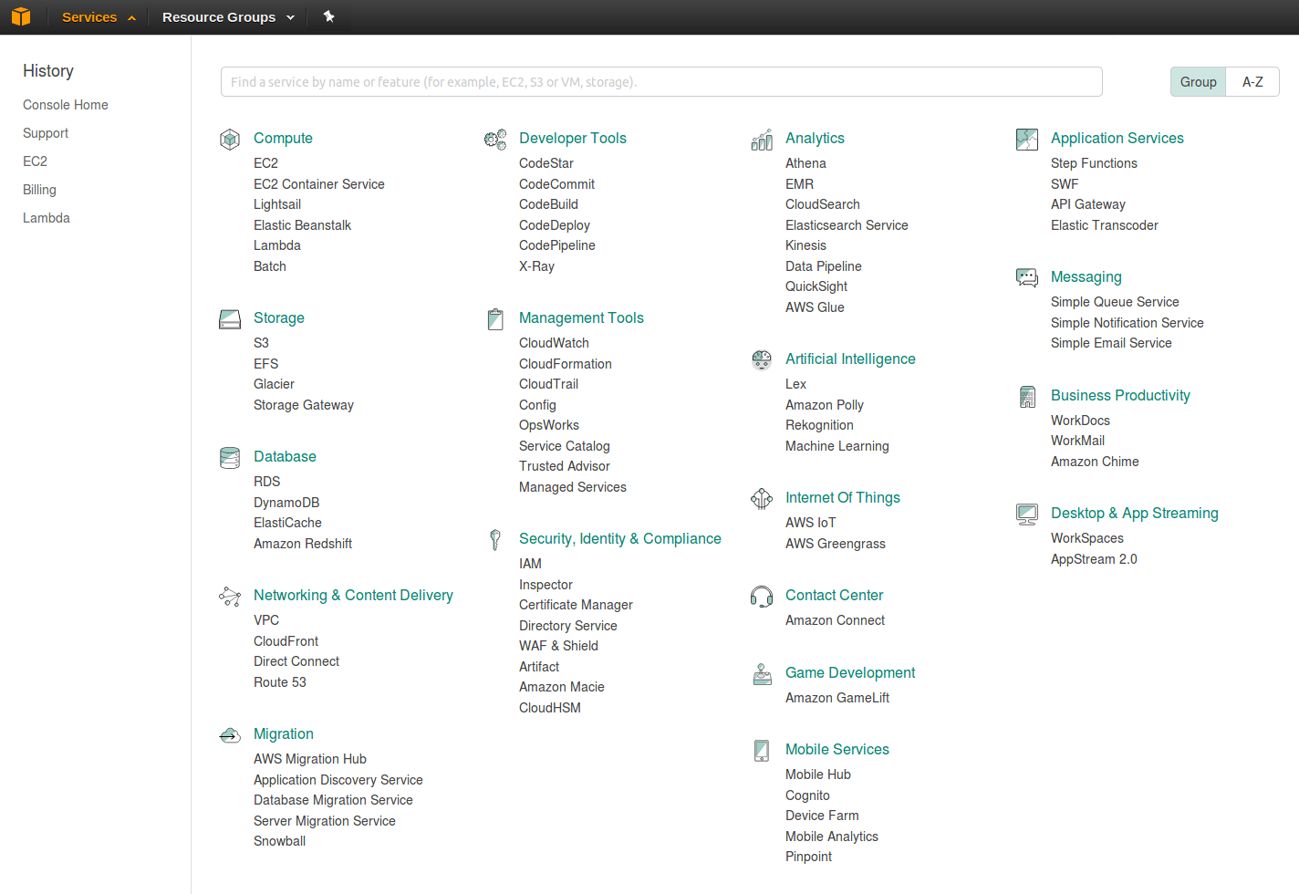](https://classroom.udacity.com/nanodegrees/nd209/parts/c199593e-1e9a-4830-8e29-2c86f70f489e/modules/cac27683-d5f4-40b4-82ce-d708de8f5373/lessons/197a058e-44f6-47df-8229-0ce633e0a2d0/concepts/27c73209-5d7b-4284-8315-c0e07a7cd87f)](https://classroom.udacity.com/nanodegrees/nd209/parts/c199593e-1e9a-4830-8e29-2c86f70f489e/modules/cac27683-d5f4-40b4-82ce-d708de8f5373/lessons/197a058e-44f6-47df-8229-0ce633e0a2d0/concepts/27c73209-5d7b-4284-8315-c0e07a7cd87f)**

**2.** To open a list of your EC2 instances Select **Instances** from the left side panel.

**3.** Now, select your instance from the Instances table and click the **Connect** button at the top of the screen.

**[[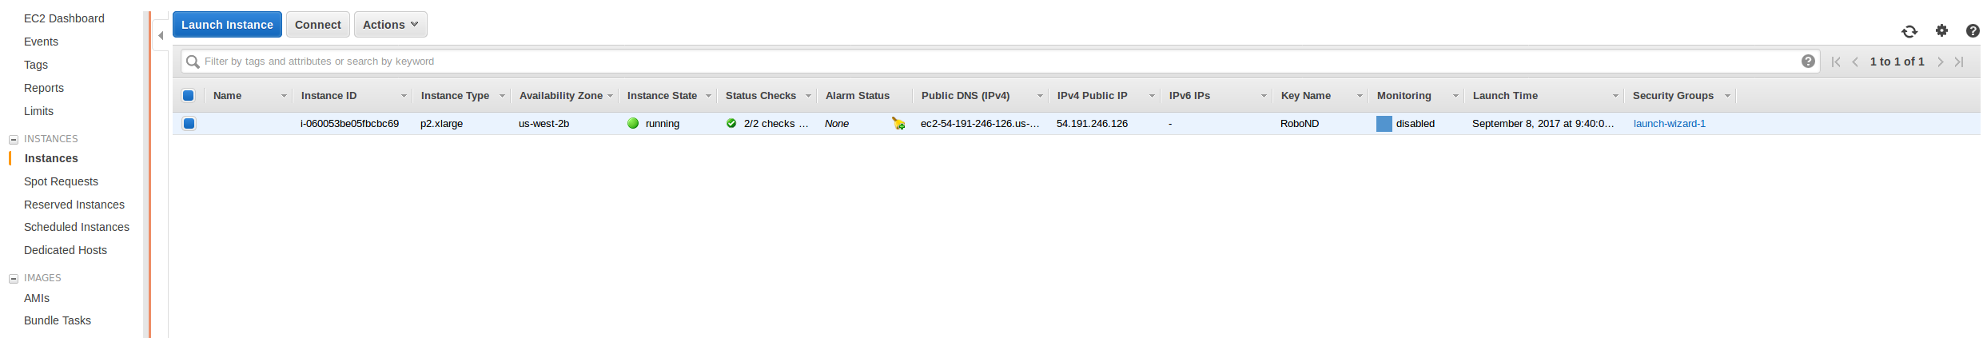](https://classroom.udacity.com/nanodegrees/nd209/parts/c199593e-1e9a-4830-8e29-2c86f70f489e/modules/cac27683-d5f4-40b4-82ce-d708de8f5373/lessons/197a058e-44f6-47df-8229-0ce633e0a2d0/concepts/27c73209-5d7b-4284-8315-c0e07a7cd87f)](https://classroom.udacity.com/nanodegrees/nd209/parts/c199593e-1e9a-4830-8e29-2c86f70f489e/modules/cac27683-d5f4-40b4-82ce-d708de8f5373/lessons/197a058e-44f6-47df-8229-0ce633e0a2d0/concepts/27c73209-5d7b-4284-8315-c0e07a7cd87f)**

**4.** Open a new terminal window on your system.

**5.** $cd to the location where you have stored your private key and change it's permissions

$ chmod 400 your\_key.pem

**6.** Amazon provides you the ssh command to connect to your instance using its Public DNS. But you need to modify that command such that you are logging in as **ubuntu** and not **root**. For example if the suggestion from amazon is:

$ ssh -i "first\_key\_pair.pem" root@ec2-52-43-242-129.us-west-2.compute.amazonaws.com

you must change it to:

$ ssh -i "first\_key\_pair.pem" ubuntu@ec2-52-43-242-129.us-west-2.compute.amazonaws.com

**7.** **Note:** Do not copy the above line into your terminal directly, copy the line in Connect to Your Instance dialog with above stated modification.

**[[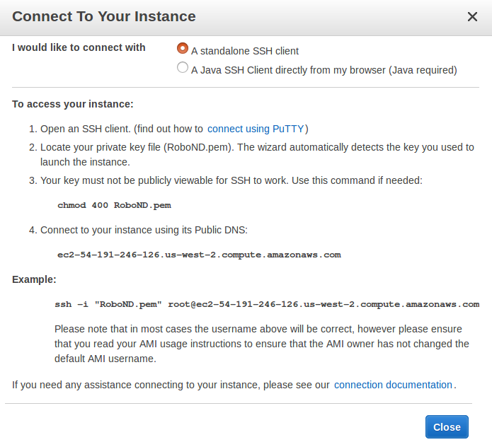](https://classroom.udacity.com/nanodegrees/nd209/parts/c199593e-1e9a-4830-8e29-2c86f70f489e/modules/cac27683-d5f4-40b4-82ce-d708de8f5373/lessons/197a058e-44f6-47df-8229-0ce633e0a2d0/concepts/27c73209-5d7b-4284-8315-c0e07a7cd87f)](https://classroom.udacity.com/nanodegrees/nd209/parts/c199593e-1e9a-4830-8e29-2c86f70f489e/modules/cac27683-d5f4-40b4-82ce-d708de8f5373/lessons/197a058e-44f6-47df-8229-0ce633e0a2d0/concepts/27c73209-5d7b-4284-8315-c0e07a7cd87f)**

**8.** Type yes when asked if you want to connect. You should now have access to your EC2 instance within your active terminal.

## Connecting to an EC2 Instance (Windows)

If you are trying to connect/ssh into your EC2 instance on a Windows machine, you can follow the detailed guide here - [**Connecting to Your Linux Instance from Windows Using PuTTY**](https://docs.aws.amazon.com/AWSEC2/latest/UserGuide/putty.html)

## Launching a Jupyter Notebook from your instance

So long as you have set up your security group as mentioned above for Jupyter notebooks there are only two steps needed to launch the notebook in your local browser.

**1.** In a terminal that is connected to your AWS instance run $ jupyter notebook --ip='\*' --port=8888 --no-browser

**2.** Then open a local browser and enter public\_ip:8888 where public\_ip is the ip of your AWS instance.

From there the Jupyter notebook will launch in the browser. If it asks you for a token or password, look at the terminal in which you stated the Jupyter notebook and you can find the this line http://localhost:8888/?token=c94cca11b154c6c25f834e55837449c18fa65b2979043170 in which c94cca11b154c6c25f834e55837449c18fa65b2979043170 is the password to the notebook.

## Disconnecting and Stopping an instance

* To simply disconnect from a connected instance. Type $exit in your active terminal.
* If you are no longer using an instance and want to stop it **temporarily**, select your instance from the list then click **Actions > Instance State > Stop**

**[[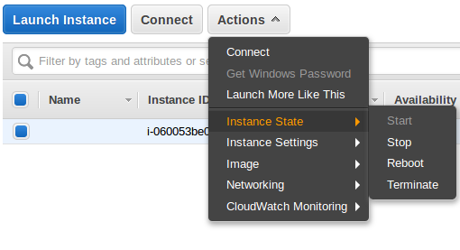](https://classroom.udacity.com/nanodegrees/nd209/parts/c199593e-1e9a-4830-8e29-2c86f70f489e/modules/cac27683-d5f4-40b4-82ce-d708de8f5373/lessons/197a058e-44f6-47df-8229-0ce633e0a2d0/concepts/27c73209-5d7b-4284-8315-c0e07a7cd87f)](https://classroom.udacity.com/nanodegrees/nd209/parts/c199593e-1e9a-4830-8e29-2c86f70f489e/modules/cac27683-d5f4-40b4-82ce-d708de8f5373/lessons/197a058e-44f6-47df-8229-0ce633e0a2d0/concepts/27c73209-5d7b-4284-8315-c0e07a7cd87f)**

* **Remember**, when you stop an instance, it is shut down by AWS. You will not be charged hourly usage for a stopped instance but you will be charged for any Amazon EBS storage volumes. Each time you start a stopped instance you will be charged a full instance hour, even if you make this transition multiple times within a single hour.
* To avoid accumulating charges you should **terminate** your instance. Terminating your instance will result in losing all access, so it's better to make sure that you backup any code and data. You can do so by either transferring the files from AWS to your host computer, or by uploading the changes to your GitHub repo.
* More information on Starting & Stopping an instance can be found [**here**](https://docs.aws.amazon.com/AWSEC2/latest/UserGuide/Stop_Start.html)

**04 – Working with the Simulator**

### Welcome to the Uda-City Simulator

Upon launching your OS executable, you will land on the following screen.

**[[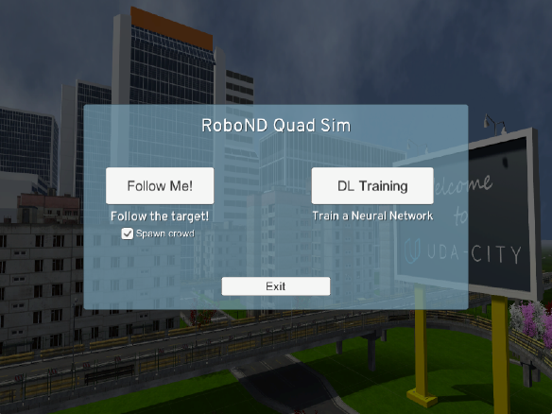](https://classroom.udacity.com/nanodegrees/nd209/parts/c199593e-1e9a-4830-8e29-2c86f70f489e/modules/cac27683-d5f4-40b4-82ce-d708de8f5373/lessons/197a058e-44f6-47df-8229-0ce633e0a2d0/concepts/18f7a89e-7829-478c-998a-fb154e49dbcc)](https://classroom.udacity.com/nanodegrees/nd209/parts/c199593e-1e9a-4830-8e29-2c86f70f489e/modules/cac27683-d5f4-40b4-82ce-d708de8f5373/lessons/197a058e-44f6-47df-8229-0ce633e0a2d0/concepts/18f7a89e-7829-478c-998a-fb154e49dbcc)**

The dialogue box presents you with two choices: (1) DL Training and (2) Follow Me!. DL Training is used to gather the training data - more on this later. The Follow Me! option is how you will evaluate the quality of your trained network!

When you are active in the simulator you can use the following keyboard controls:

**L:** Turns the legend with the control information on and off

**H:** Enables and disables local control of the quad

**WSAD/Arrows:** Moves the quad around when local control is on

**E/Q:** Rotate the quad clockwise and counterclockwise respectively

**Space/C:** Increase and decrease the thrust of the quad when local control is on

**Scroll wheel:** Zooms the camera in and out

**Right mouse button (drag):** Rotates the camera around the quad

**Right mouse button (click):** Resets the camera

**Middle mouse button:** Toggle patrol and follow mode

**G:** Reset the quad orientation

**F5:** Cycle quality settings

**/:** Path display on/off

**ESC:** Exit to the main menu

**Crtl-Q:** Quit

**05-Collecting your data**

# Data Guide

A simple training dataset has been provided in this project's repository. This dataset will allow you to verify that you're segmentation network is semi-functional. However, if you're interested in improving your score, you may want to collect additional training data. To do it, please see the following steps.

The data directory is organized as follows:

data/runs - contains the results of prediction runs

data/train/images - contains images for the training set

data/train/masks - contains masked (labeled) images for the training set

data/validation/images - contains images for the validation set

data/validation/masks - contains masked (labeled) images for the validation set

data/weights - contains trained TensorFlow models

data/raw\_sim\_data/train/run1

data/raw\_sim\_data/validation/run1

### Training Set

1. Run QuadSim
2. Click the DL Training button
3. Set patrol points, path points, and spawn points as taught below in the next lesson Data Collection Guide
4. With the simulator running, press "r" to begin recording.
5. In the file selection menu navigate to the data/raw\_sim\_data/train/run1 directory
6. **Optional:** to speed up data collection, press "9" (1-9 will slow down collection speed)
7. When you have finished collecting data, hit "r" to stop recording.
8. To reset the simulator, hit "<esc>"
9. To collect multiple runs create directories data/raw\_sim\_data/train/run2, data/raw\_sim\_data/train/run3 and repeat the above steps.

### Validation Set

To collect the validation set, repeat both sets of steps above, except using the directory data/raw\_sim\_data/validation instead rather than data/raw\_sim\_data/train.

### Image Preprocessing

Before the network is trained, the images first need to undergo a preprocessing step. The preprocessing step transforms the depth masks from the sim, into binary masks suitable for training a neural network. It also converts the images from .png to .jpeg to create a reduced sized dataset, suitable for uploading to AWS. To run preprocessing:

$ python preprocess\_ims.py

**Note**: If your data is stored as suggested in the steps above, this script should run without error.

**Important Note 1:**

Running preprocess\_ims.py does not delete files in the processed\_data folder. This means if you leave images in processed data and collect a new dataset, some of the data in processed\_data will be overwritten some will be left as is. It is recommended to **delete** the train and validation folders inside processed\_data(or the entire folder) before running preprocess\_ims.py with a new set of collected data.

**Important Note 2:**

The notebook, and supporting code assume your data for training/validation is in data/train, and data/validation. After you run preprocess\_ims.py you will have new train, and possibly validationfolders in the processed\_ims. Rename or move data/train, and data/validation, then move data/processed\_ims/train, into data/, anddata/processed\_ims/validationalso into data/

**Important Note 3:**

Merging multiple train or validation may be difficult, it is recommended that data choices be determined by what you include in raw\_sim\_data/train/run1 with possibly many different runs in the directory. You can create a tempory folder in data/ and store raw run data you don't currently want to use, but that may be useful for later. Choose which run\_x folders to include in raw\_sim\_data/train, and raw\_sim\_data/validation, then run preprocess\_ims.py from within the 'code/' directory to generate your new training and validation sets.

**06- Data Collection Guide**

## Data Collection Guide

Lets get started collecting data for our network. Good data is just as important as a good network architecture, so collecting the best data you can is a key to success!

**Note: Some screen images may differ from your current simulator build but the keys and the process remain the same.**

Open quad sim, put a check mark in Spawn crowd, then click on DL training

**[[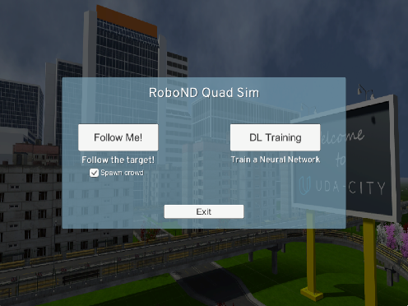](https://classroom.udacity.com/nanodegrees/nd209/parts/c199593e-1e9a-4830-8e29-2c86f70f489e/modules/cac27683-d5f4-40b4-82ce-d708de8f5373/lessons/197a058e-44f6-47df-8229-0ce633e0a2d0/concepts/764666fe-b285-4b19-ac2f-02217084455a)](https://classroom.udacity.com/nanodegrees/nd209/parts/c199593e-1e9a-4830-8e29-2c86f70f489e/modules/cac27683-d5f4-40b4-82ce-d708de8f5373/lessons/197a058e-44f6-47df-8229-0ce633e0a2d0/concepts/764666fe-b285-4b19-ac2f-02217084455a)**

### Local control mode

The quad will start out in patrol mode, but since we have not added any waypoints yet, it will have nowhere to go. To add waypoints you must first switch to local local control by pressing the H key.

**[[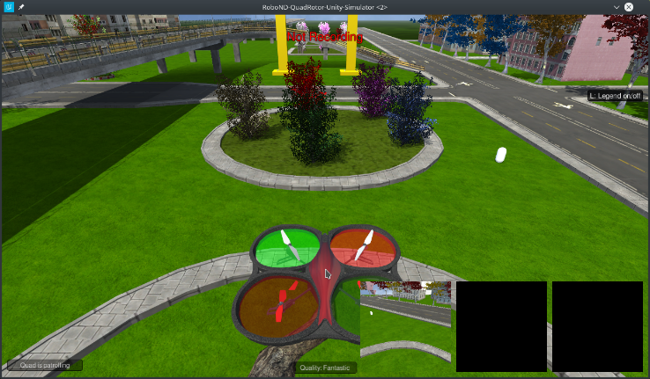](https://classroom.udacity.com/nanodegrees/nd209/parts/c199593e-1e9a-4830-8e29-2c86f70f489e/modules/cac27683-d5f4-40b4-82ce-d708de8f5373/lessons/197a058e-44f6-47df-8229-0ce633e0a2d0/concepts/764666fe-b285-4b19-ac2f-02217084455a)](https://classroom.udacity.com/nanodegrees/nd209/parts/c199593e-1e9a-4830-8e29-2c86f70f489e/modules/cac27683-d5f4-40b4-82ce-d708de8f5373/lessons/197a058e-44f6-47df-8229-0ce633e0a2d0/concepts/764666fe-b285-4b19-ac2f-02217084455a)**

### View and Navigation

* To zoom out from the quad, we recommend using the mouse wheel.
* To change the viewing perspective at any time during training, right click on the screen and move the mouse.
* Use WASD keys to move the quad forward, left, back and right
* Use <space> and C to thrust up and down
* Use QE keys to turn the quad toward the left or right
* Press G to reset it to the starting pose.
* To look up these and other commands press the L legend key

**[[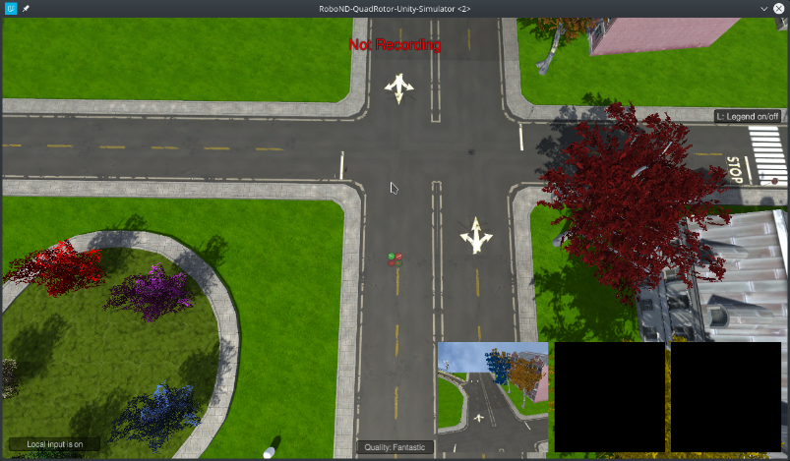](https://classroom.udacity.com/nanodegrees/nd209/parts/c199593e-1e9a-4830-8e29-2c86f70f489e/modules/cac27683-d5f4-40b4-82ce-d708de8f5373/lessons/197a058e-44f6-47df-8229-0ce633e0a2d0/concepts/764666fe-b285-4b19-ac2f-02217084455a)](https://classroom.udacity.com/nanodegrees/nd209/parts/c199593e-1e9a-4830-8e29-2c86f70f489e/modules/cac27683-d5f4-40b4-82ce-d708de8f5373/lessons/197a058e-44f6-47df-8229-0ce633e0a2d0/concepts/764666fe-b285-4b19-ac2f-02217084455a)**

### Managing data collection

There are 3 major aspects to the data collection process that you can control in order determine the type of data you collect. These are as follows:

1. The path the quad will take while on patrol.
2. The path the hero will walk.
3. The locations of distractor spawns.

**Setting Patrol Points**

Press the P key to set a patrol point. A green patrol point will appear at the quads position.

**[[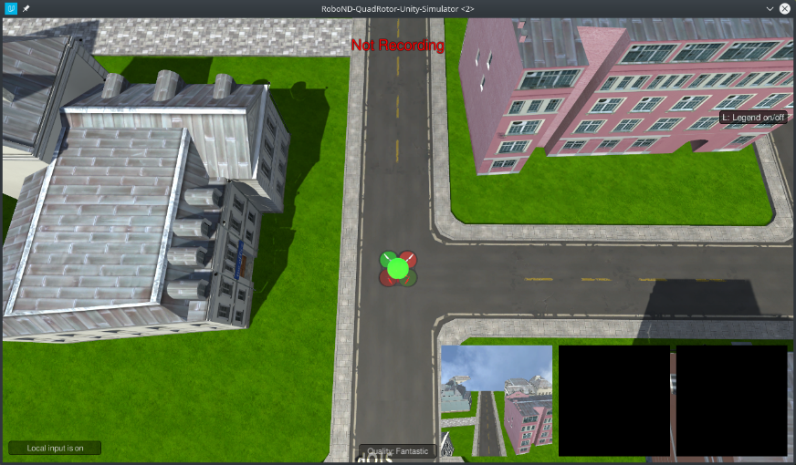](https://classroom.udacity.com/nanodegrees/nd209/parts/c199593e-1e9a-4830-8e29-2c86f70f489e/modules/cac27683-d5f4-40b4-82ce-d708de8f5373/lessons/197a058e-44f6-47df-8229-0ce633e0a2d0/concepts/764666fe-b285-4b19-ac2f-02217084455a)](https://classroom.udacity.com/nanodegrees/nd209/parts/c199593e-1e9a-4830-8e29-2c86f70f489e/modules/cac27683-d5f4-40b4-82ce-d708de8f5373/lessons/197a058e-44f6-47df-8229-0ce633e0a2d0/concepts/764666fe-b285-4b19-ac2f-02217084455a)**

Move to another position and press P again to add one more patrol point somewhere nearby.

**[[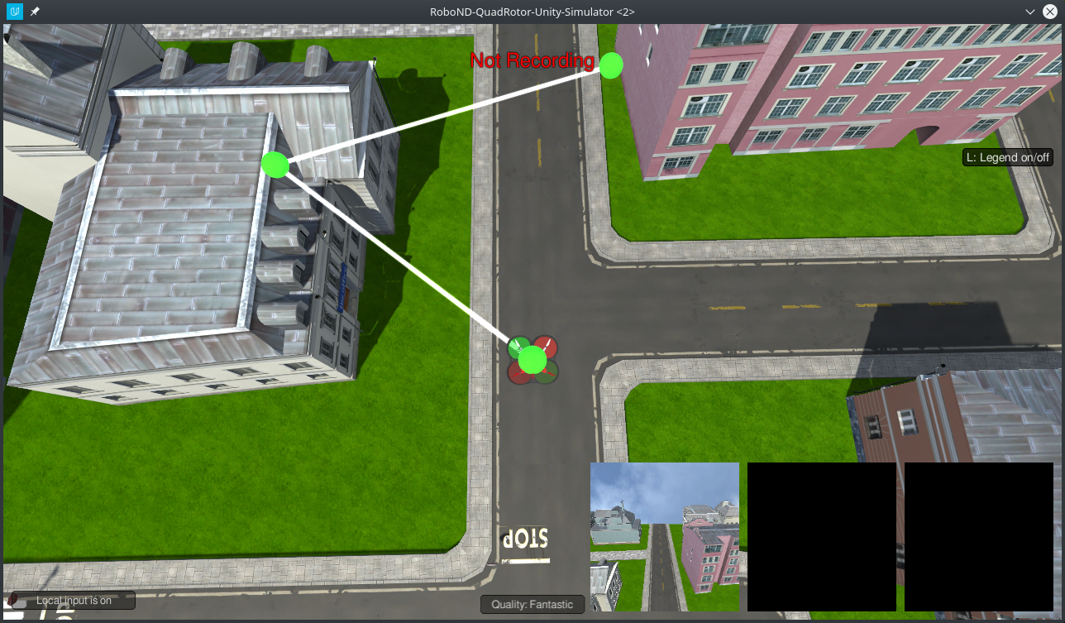](https://classroom.udacity.com/nanodegrees/nd209/parts/c199593e-1e9a-4830-8e29-2c86f70f489e/modules/cac27683-d5f4-40b4-82ce-d708de8f5373/lessons/197a058e-44f6-47df-8229-0ce633e0a2d0/concepts/764666fe-b285-4b19-ac2f-02217084455a)](https://classroom.udacity.com/nanodegrees/nd209/parts/c199593e-1e9a-4830-8e29-2c86f70f489e/modules/cac27683-d5f4-40b4-82ce-d708de8f5373/lessons/197a058e-44f6-47df-8229-0ce633e0a2d0/concepts/764666fe-b285-4b19-ac2f-02217084455a)**

You can now put the quad into patrol mode by pressing H. To switch back to local control press H again.

To remove all the patrol points you have set press L

**[[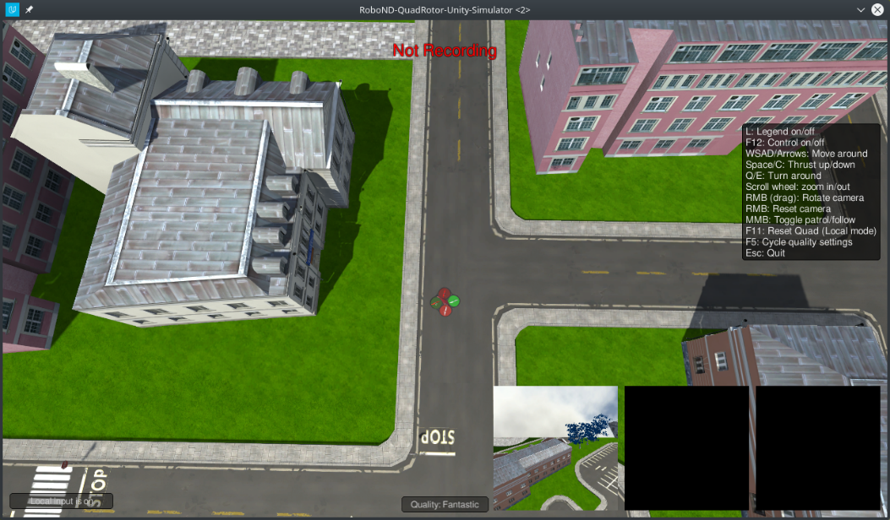](https://classroom.udacity.com/nanodegrees/nd209/parts/c199593e-1e9a-4830-8e29-2c86f70f489e/modules/cac27683-d5f4-40b4-82ce-d708de8f5373/lessons/197a058e-44f6-47df-8229-0ce633e0a2d0/concepts/764666fe-b285-4b19-ac2f-02217084455a)](https://classroom.udacity.com/nanodegrees/nd209/parts/c199593e-1e9a-4830-8e29-2c86f70f489e/modules/cac27683-d5f4-40b4-82ce-d708de8f5373/lessons/197a058e-44f6-47df-8229-0ce633e0a2d0/concepts/764666fe-b285-4b19-ac2f-02217084455a)**

**Setting Hero Path Points**

To set a hero path point press O while in local control mode. The hero path points are very similar to the patrol points, except they are always placed at ground level. Decrease the quads altitude by pressing C to get a better look at the points you are setting. Similar to patrol points, all the hero path points can be removed by pressing K. The hero will start at the first point you create and walk around the path. When reaching the end, the hero will despawn before reappearing at the beginning of the path.

**[[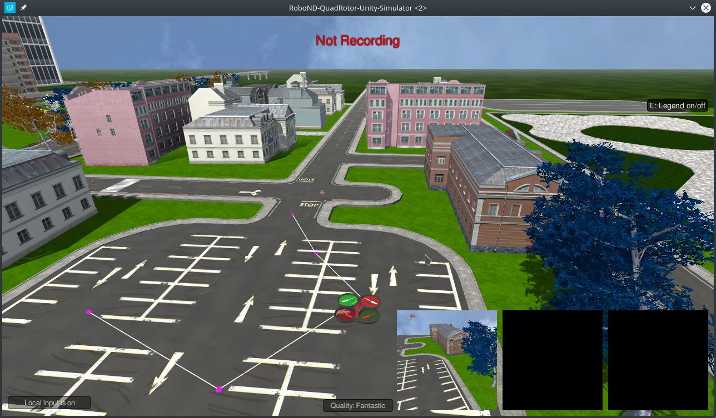](https://classroom.udacity.com/nanodegrees/nd209/parts/c199593e-1e9a-4830-8e29-2c86f70f489e/modules/cac27683-d5f4-40b4-82ce-d708de8f5373/lessons/197a058e-44f6-47df-8229-0ce633e0a2d0/concepts/764666fe-b285-4b19-ac2f-02217084455a)](https://classroom.udacity.com/nanodegrees/nd209/parts/c199593e-1e9a-4830-8e29-2c86f70f489e/modules/cac27683-d5f4-40b4-82ce-d708de8f5373/lessons/197a058e-44f6-47df-8229-0ce633e0a2d0/concepts/764666fe-b285-4b19-ac2f-02217084455a)**

**Setting Spawn Points**

All the characters in the sim except the hero will respawn after 30-50 seconds at one of the spawn points. You can control the number of people in a given area by the number and location of the spawn points you place. You can set a spawn point at the quads current x,y position by pressing the I key. Blue markers will appear at the spawn locations. You can remove all the spawn points by pressing J

**[[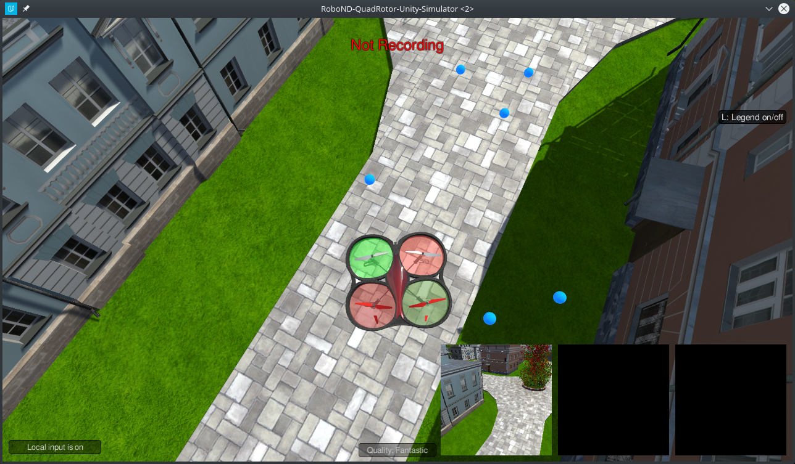](https://classroom.udacity.com/nanodegrees/nd209/parts/c199593e-1e9a-4830-8e29-2c86f70f489e/modules/cac27683-d5f4-40b4-82ce-d708de8f5373/lessons/197a058e-44f6-47df-8229-0ce633e0a2d0/concepts/764666fe-b285-4b19-ac2f-02217084455a)](https://classroom.udacity.com/nanodegrees/nd209/parts/c199593e-1e9a-4830-8e29-2c86f70f489e/modules/cac27683-d5f4-40b4-82ce-d708de8f5373/lessons/197a058e-44f6-47df-8229-0ce633e0a2d0/concepts/764666fe-b285-4b19-ac2f-02217084455a)**

**Setting up a Data Collection Run**

For setting spawn and hero path points it is helpful to rotate the camera so you are viewing the quad from directly above.

**[[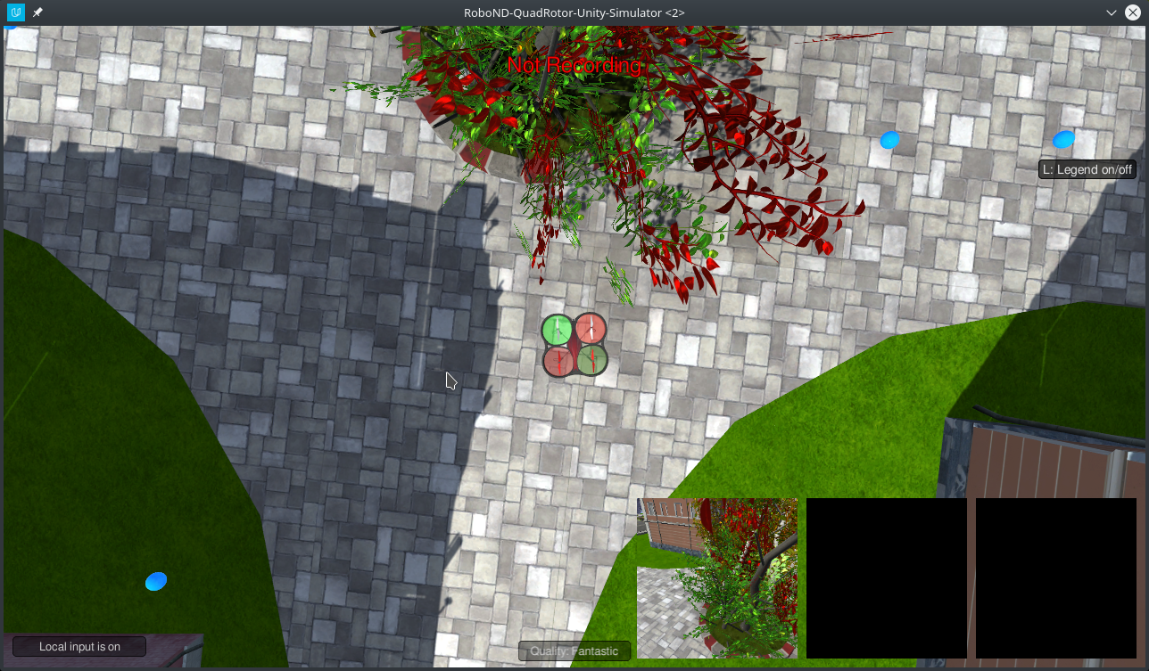](https://classroom.udacity.com/nanodegrees/nd209/parts/c199593e-1e9a-4830-8e29-2c86f70f489e/modules/cac27683-d5f4-40b4-82ce-d708de8f5373/lessons/197a058e-44f6-47df-8229-0ce633e0a2d0/concepts/764666fe-b285-4b19-ac2f-02217084455a)](https://classroom.udacity.com/nanodegrees/nd209/parts/c199593e-1e9a-4830-8e29-2c86f70f489e/modules/cac27683-d5f4-40b4-82ce-d708de8f5373/lessons/197a058e-44f6-47df-8229-0ce633e0a2d0/concepts/764666fe-b285-4b19-ac2f-02217084455a)**

To start let's create a small collection experiment. Often it will be the case that you will want to run multiple collection runs and have each run target a specific type of data. It will also be necessary to have a large sample of data containing the hero. If you create a very large patrol path and hero path it will be unlikely that you will collect many images containing the hero.

**[[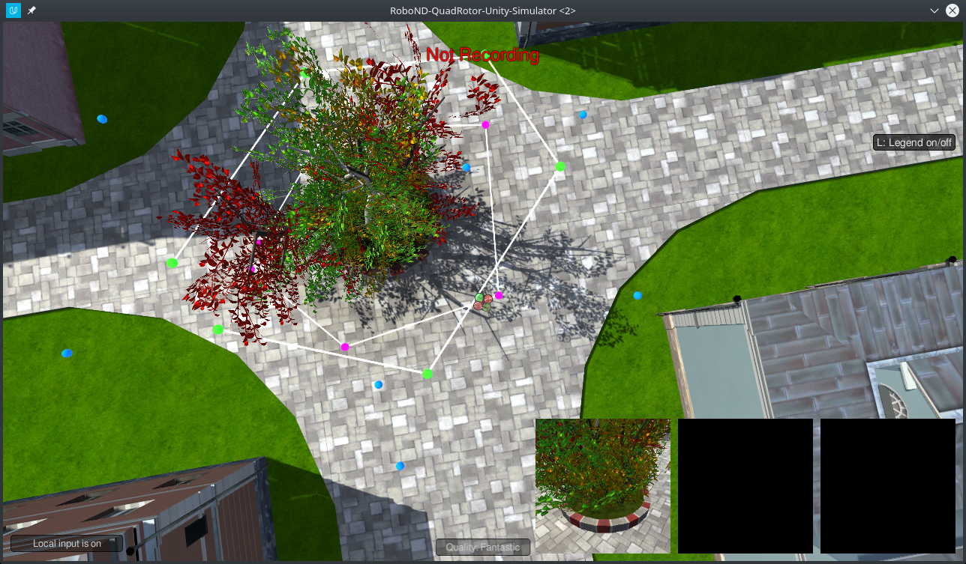](https://classroom.udacity.com/nanodegrees/nd209/parts/c199593e-1e9a-4830-8e29-2c86f70f489e/modules/cac27683-d5f4-40b4-82ce-d708de8f5373/lessons/197a058e-44f6-47df-8229-0ce633e0a2d0/concepts/764666fe-b285-4b19-ac2f-02217084455a)](https://classroom.udacity.com/nanodegrees/nd209/parts/c199593e-1e9a-4830-8e29-2c86f70f489e/modules/cac27683-d5f4-40b4-82ce-d708de8f5373/lessons/197a058e-44f6-47df-8229-0ce633e0a2d0/concepts/764666fe-b285-4b19-ac2f-02217084455a)**

**Starting the Collection Run**

When you are satisfied with how you have placed the the patrol path, hero path, and spawn points, press M to have people start spawning.

**[[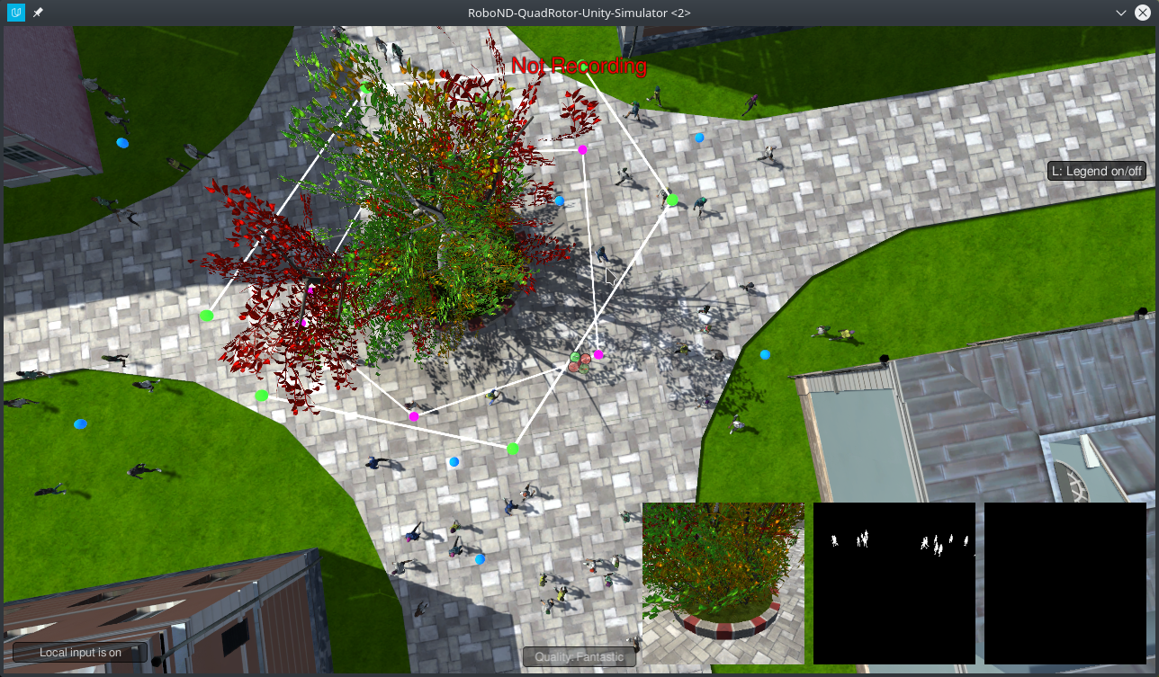](https://classroom.udacity.com/nanodegrees/nd209/parts/c199593e-1e9a-4830-8e29-2c86f70f489e/modules/cac27683-d5f4-40b4-82ce-d708de8f5373/lessons/197a058e-44f6-47df-8229-0ce633e0a2d0/concepts/764666fe-b285-4b19-ac2f-02217084455a)](https://classroom.udacity.com/nanodegrees/nd209/parts/c199593e-1e9a-4830-8e29-2c86f70f489e/modules/cac27683-d5f4-40b4-82ce-d708de8f5373/lessons/197a058e-44f6-47df-8229-0ce633e0a2d0/concepts/764666fe-b285-4b19-ac2f-02217084455a)**

To start recording data press the R key. Navigate to the raw\_sim\_data/train/target We are using the target directory because we have elected to have the hero appear in this collection run. Alternatively randomly chosen people can take the role of the hero. In this in order to have the data preparation turn out correctly you would select the non\_target folder.

**[[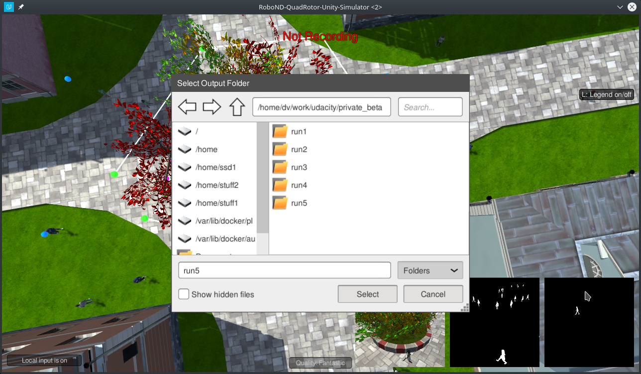](https://classroom.udacity.com/nanodegrees/nd209/parts/c199593e-1e9a-4830-8e29-2c86f70f489e/modules/cac27683-d5f4-40b4-82ce-d708de8f5373/lessons/197a058e-44f6-47df-8229-0ce633e0a2d0/concepts/764666fe-b285-4b19-ac2f-02217084455a)](https://classroom.udacity.com/nanodegrees/nd209/parts/c199593e-1e9a-4830-8e29-2c86f70f489e/modules/cac27683-d5f4-40b4-82ce-d708de8f5373/lessons/197a058e-44f6-47df-8229-0ce633e0a2d0/concepts/764666fe-b285-4b19-ac2f-02217084455a)**

Another import note. It is a good idea to restart the sim before trying to set up another data collection run (very much recommended)

Inside the target/non\_target folder there can be any number of runfolders. Using the same run folder multiple times will result in the data from the first run being deleted and replaced with data from the second run. Press the select button and the indicator at the top of the screen should change to green, which means that data is being collected.

**[[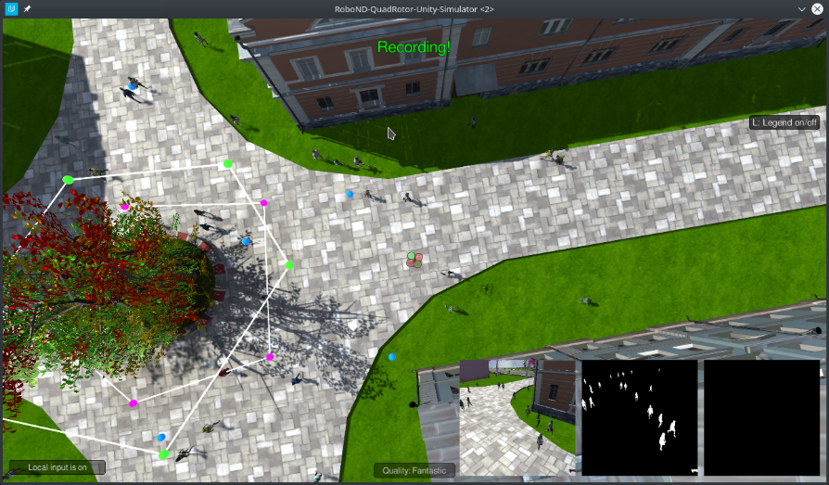](https://classroom.udacity.com/nanodegrees/nd209/parts/c199593e-1e9a-4830-8e29-2c86f70f489e/modules/cac27683-d5f4-40b4-82ce-d708de8f5373/lessons/197a058e-44f6-47df-8229-0ce633e0a2d0/concepts/764666fe-b285-4b19-ac2f-02217084455a)](https://classroom.udacity.com/nanodegrees/nd209/parts/c199593e-1e9a-4830-8e29-2c86f70f489e/modules/cac27683-d5f4-40b4-82ce-d708de8f5373/lessons/197a058e-44f6-47df-8229-0ce633e0a2d0/concepts/764666fe-b285-4b19-ac2f-02217084455a)**

Press H to have the quad enter patrol mode. To speed up the data collection process, press the 9 key. Data from this run will be stored in the folder you selected.

When you are done collecting data, you can press R again to stop recording. While it is not advisable to add/remove the hero path/spawn points while the data collection is running, you can delete the patrol path and modify it if desired.

To reset the sim, press <Esc>

### Data Collection Best Practices

Let's take some time to go over best practices when recording data for this project.

Starting with data you should aim to collect:

* Data gathered by following the hero in a very dense crowd.
* Data gathered while in patrol directly over the hero, while they zigzag.
* Data gathered while the quad is on standard patrol.

**Collecting data using a data collection run:**

The simplest way to collect extra data is to simply DL training and press <M> to start the spawns. Then start recording. Lets take a look at what happens when we do this and use the data to train a neural network. three thousand images, collected in this manner have been provided for you, and you are welcome to collect more, but you will quickly find that even adding many many images will not improve your score that much.

**Collecting data in follow mode**

One third of the grading data is based on the centroid accuracy in while following the target person. To collect data that will prepare the neural network for these situations, we create two custom data collection runs. To start run the sim and select DL training mode. Then press 'j', 'k', then 'l' to clear the task waypoints.

**Trying to get all angles of hero using patrol:**

For this idea we will have two patrol points. then directly under the patrol path, create a zigzagging path for the hero. I found it helpful to have the patrol path move quite outside of the boundery of the hero path because of the angle of the gimbal camera.

**Collecting data from the full path:**

While thats saving data, I will also start collecting some data from the full patrol path. This data will not have the hero in it, but it is important so the network can learn to account for objects that look like the hero.

**Last idea is to concentrate the collection of the hero data in dense crowd:**

To get an idea of how this can look, please take a look at the video below.

**07-Building your Segmentation Network**

## Your tasks!

In order build a reliable network to work with the simulator, you need to implement code in the model\_training.ipynb file.

You will need to fill out the encoder block as so:

**def** **encoder\_block**(input\_layer, filters, strides):

*# TODO Create a separable convolution layer using the*

*# separable\_conv2d\_batchnorm() function.*

**return** output\_layer

Then the decoder block:

**def** **decoder\_block**(small\_ip\_layer, large\_ip\_layer, filters):

*# TODO Upsample the small input layer using the bilinear\_upsample() function.*

*# TODO Concatenate the upsampled and large input layers using*

*# layers.concatenate.*

*# TODO Add some number of separable convolution layers.*

**return** output\_layer

And now the network itself:

**def** **fcn\_model**(inputs, num\_classes):

*# TODO Add Encoder Blocks.*

*# Remember that with each encoder layer, the depth of your model (the number of filters) increases.*

*# TODO Add 1x1 Convolution layer using conv2d\_batchnorm().*

*# TODO: Add the same number of Decoder Blocks as the number of Encoder Blocks*

*# The function returns the output layer of your model. "x" is the final layer obtained from the last decoder\_block()*

**return** layers.Conv2D(num\_classes, 1, activation='softmax', padding='same')(x)

These can be completed with what you learned from the lab. Most of the concepts you learned in the lab are transferable here, but feel free to explore some more by customizing the network as you see fit!

After you have built your network its time to pick hyper parameters:

learning\_rate = 0

batch\_size = 0

num\_epochs = 0

steps\_per\_epoch = 200

validation\_steps = 50

workers = 2

This can also be completed using what you learned in the lab. But remember, to get better performance you may need to optimize various hyperparameters, such as the learning rate and batch size (and others!), in order to increase overall network performance.

**08-Training and Validation**

## Training, Predicting and Scoring

Now that you have collected your data and built your network, it's time to train your data and test its performance on the validation set.

**Note**: Training CNNs is a very compute-intensive process. If your system does not have a recent Nvidia graphics card, with **[cuDNN](https://developer.nvidia.com/cudnn" \t "_blank)** and **[CUDA](https://developer.nvidia.com/cuda" \t "_blank)**installed , you may need to perform the training step in the cloud. Instructions for using AWS to train your network in the cloud may be found [**here**](https://classroom.udacity.com/nanodegrees/nd209/parts/c199593e-1e9a-4830-8e29-2c86f70f489e/modules/cac27683-d5f4-40b4-82ce-d708de8f5373/lessons/197a058e-44f6-47df-8229-0ce633e0a2d0/concepts/27c73209-5d7b-4284-8315-c0e07a7cd87f?contentVersion=1.0.0&contentLocale=en-us)

### Training your Model

**Prerequisites**

* Training data is in data directory
* Validation data is in the data directory
* The folders data/train/images/, data/train/masks/, data/validation/images/, and data/validation/masks/ should exist and contain the appropriate data

To train complete the TODO's in the model\_training.ipynb notebook and then run the training cell with appropriate hyperparameters selected.

After the training run has completed, your model will be stored in the data/weights directory as an [**HDF5**](https://en.wikipedia.org/wiki/Hierarchical_Data_Format) file, and a configuration\_weights file. As long as they are both in the same location, things should work.

**Important Note** the validation directory is used to store data that will be used during training to produce the plots of the loss, and help determine when the network is overfitting your data.

The **sample\_evalution\_data** directory contains data specifically designed to test the networks performance on the FollowME task. In sample\_evaluation data are three directories each generated using a different sampling method. The structure of these directories is exactly the same as validation, and train datasets provided to you. For instance patrol\_with\_targ contains an images and masks subdirectory. If you would like to the evaluation code on your validation data a copy of the it should be moved into sample\_evaluation\_data, and then the appropriate arguments changed to the function calls in the model\_training.ipynb notebook.

The notebook has examples of how to evaulate your model once you finish training. Think about the socring methods, and how the information provided in the evaluation sections relates to the final score. Then try things out seem like they may work.

## Scoring

To score the network on the FollowMe task two types of error are measured. First the intersection over the union for the pixelwise classifications is computed for the target channel.

In addition to this we determine whether the network detected the target person or not. If more then 3 pixels have probability greater then 0.5 of being the target person then this counts as the network guessing the target is in the image.

We determine whether the target is actually in the image by whether there are more then 3 pixels containing the target in the label mask.

Using the above the number of detection true\_positives, false positives, false negatives are counted.

**How the Final Score is Calculated**

The final score is the pixel wise:

average\_IoU\*(n\_true\_positive/(n\_true\_positive+n\_false\_positive+n\_false\_negative))

on data similar to that provided in sample\_evaulation\_data

**Ideas for Improving your Score**

Collect more data from the sim. Look at the predictions think about what the network is getting wrong, then collect data to counteract this. Or improve your network architecture and hyperparameters.

**Obtaining a leaderboard score**

Share your scores in slack, and keep a tally in a pinned message. Scores should be computed on the sample\_evaluation\_data. This is for fun, your grade will be determined on unreleased data. If you use the sample\_evaluation\_data to train the network, it will result in inflated scores, and you will not be able to determine how your network will actually perform when evaluated to determine your grade.

**[[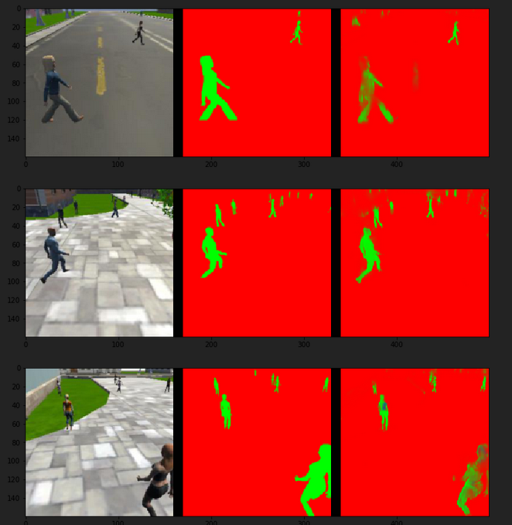](https://classroom.udacity.com/nanodegrees/nd209/parts/c199593e-1e9a-4830-8e29-2c86f70f489e/modules/cac27683-d5f4-40b4-82ce-d708de8f5373/lessons/197a058e-44f6-47df-8229-0ce633e0a2d0/concepts/f027ca23-5a7a-4fd0-8ae5-b617524a07de)](https://classroom.udacity.com/nanodegrees/nd209/parts/c199593e-1e9a-4830-8e29-2c86f70f489e/modules/cac27683-d5f4-40b4-82ce-d708de8f5373/lessons/197a058e-44f6-47df-8229-0ce633e0a2d0/concepts/f027ca23-5a7a-4fd0-8ae5-b617524a07de)**

**[Example of looking at your predictions to see where more data may help!](https://classroom.udacity.com/nanodegrees/nd209/parts/c199593e-1e9a-4830-8e29-2c86f70f489e/modules/cac27683-d5f4-40b4-82ce-d708de8f5373/lessons/197a058e-44f6-47df-8229-0ce633e0a2d0/concepts/f027ca23-5a7a-4fd0-8ae5-b617524a07de)**

**09- Testing your Model in the Simulator**

**[[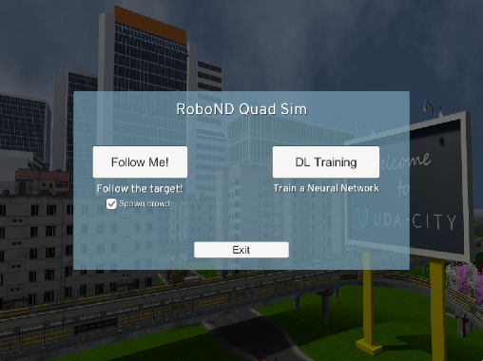](https://classroom.udacity.com/nanodegrees/nd209/parts/c199593e-1e9a-4830-8e29-2c86f70f489e/modules/cac27683-d5f4-40b4-82ce-d708de8f5373/lessons/197a058e-44f6-47df-8229-0ce633e0a2d0/concepts/0d946976-d7f3-44d7-bb15-34652eb4a8e0)](https://classroom.udacity.com/nanodegrees/nd209/parts/c199593e-1e9a-4830-8e29-2c86f70f489e/modules/cac27683-d5f4-40b4-82ce-d708de8f5373/lessons/197a058e-44f6-47df-8229-0ce633e0a2d0/concepts/0d946976-d7f3-44d7-bb15-34652eb4a8e0)**

##### Now the moment you have been waiting for, testing your model to follow and track a person!

Follow these steps on your local system to watch the quad use your model to try and follow the target:

**1.** Copy your saved model to the weights directory data/weights.

**2.** Launch the simulator, select "Spawn People", and then click the "Follow Me" button.

**3.** Run the realtime follower script

$ python follower.py my\_amazing\_model.h5

**Note:** If you'd like to see an overlay of the detected region on each camera frame from the drone, simply pass the --pred\_viz parameter to follower.py

**[[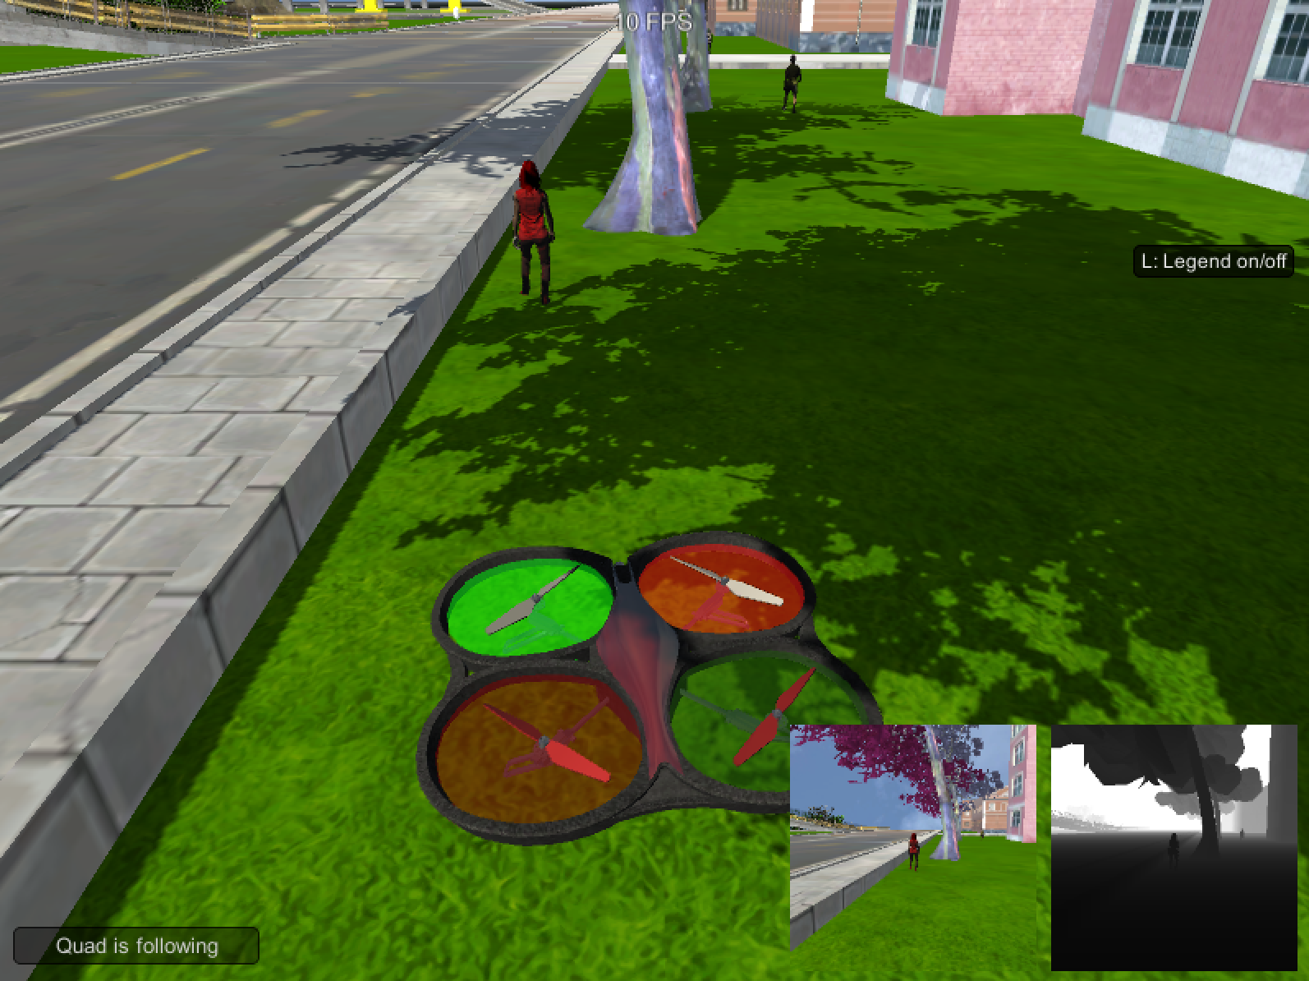](https://classroom.udacity.com/nanodegrees/nd209/parts/c199593e-1e9a-4830-8e29-2c86f70f489e/modules/cac27683-d5f4-40b4-82ce-d708de8f5373/lessons/197a058e-44f6-47df-8229-0ce633e0a2d0/concepts/0d946976-d7f3-44d7-bb15-34652eb4a8e0)](https://classroom.udacity.com/nanodegrees/nd209/parts/c199593e-1e9a-4830-8e29-2c86f70f489e/modules/cac27683-d5f4-40b4-82ce-d708de8f5373/lessons/197a058e-44f6-47df-8229-0ce633e0a2d0/concepts/0d946976-d7f3-44d7-bb15-34652eb4a8e0)**

**10-Project: Follow Me**

## Project Submission

### Follow Me Project

**Steps to complete the project:**

1. Clone the project repo [**here**](https://github.com/udacity/RoboND-DeepLearning-Project.git)
2. Fill out the TODO's in the project code as mentioned [**here**](https://classroom.udacity.com/nanodegrees/nd209/parts/c199593e-1e9a-4830-8e29-2c86f70f489e/modules/cac27683-d5f4-40b4-82ce-d708de8f5373/lessons/197a058e-44f6-47df-8229-0ce633e0a2d0/concepts/b0044631-d356-4ff4-9fd9-4102c28a2efa?contentVersion=1.0.0&contentLocale=en-us)
3. Optimize your network and hyper-parameters.
4. Train your network and achieve an accuracy of 40% (0.40) using the Intersection over Union IoU metric which is final\_grade\_score at the bottom of your notebook.
5. Make a brief writeup report summarizing why you made the choices you did in building the network.

## Evaluation

Once you have completed your project, use the [**Project Rubric**](https://review.udacity.com/#!/rubrics/1155/view) to review the project. If you have covered all of the points in the rubric, then you are ready to submit! If you see room for improvement in **any** category in which you do not meet specifications, keep working!

Your project will be evaluated by a Udacity reviewer according to the same [**Project Rubric**](https://review.udacity.com/#!/rubrics/1155/view). Your project must "meet specifications" in each category in order for your submission to pass.

## Submission

### What to include in your submission

You must submit your project as a zip file. The submission must include these items:

1. Your model\_training.ipynb notebook that you have filled out.
2. A HTML version of your model\_training.ipynb notebook.
3. Writeup report (md or pdf file)
4. Your model and weights file in the .h5 file format